**How to use (Detailed Version)**

**1. General Usage & Notes**-This is the detailed version of the how to use page. To get the simplified version, check [this.](https://drive.google.com/drive/folders/1vVYlFgIiCnCSEYeryj_L32fxcqWzz7dH?usp=drive_linkmqrKKkw1p/view?usp=drivesdk)

**+notes**-This guide is meant to be used alongside [the official Terraria wiki](https://terraria.wiki.gg/wiki/Terraria_Wiki), to look up how to obtain the gear recommended within the guide.  
-although this is a class setups guide, **it is still recommended that you use multiple weapons from other classes**, namely:  
+support weapons from the Mage class for debuff infliction and extra passive damage.  
+Minions and Sentries (and Whips) from the Summoner class for extra passive damage and crowd control.  
+Melee weapons that are effective in close range for crowd control if enemies get too close. (Vampire Knives are also very effective for survivability and inflicting debuffs)  
+Ranger weapons if enemies are too far away for your main weapon to hit.-The main folders of this class guide (1-Melee, 2-Ranger, etc) are **Boss focused**, meaning that crowd control use outside of the boss fight is not considered for the weapon rankings. For such things, please check the [events page.](https://drive.google.com/drive/folders/15CQeo8UZCsvd1joN4ZcaqqbvjkC-NIpf) And the Extra Info folder for each of the main folders.  
  
**+usage**  
-the top 2 boxes represent stage and class, the stage representing the boss(es) that the page is meant for.  
  
  
+Armor  
-*Armor sets* **are split into 2 tiers**, Best and Great. Best options are the top choices for sets which grant set bonuses. While great sets are the 2nd best, great options are usually easier to get. Please note that the armor mixing strategy is usually better.  
-*Armor Mixing* is a strategy where the player **abandons set bonuses** and instead goes for maximized stats. If a stage has no armor mix set, that usually means that the set bonus set is already the optimal option.   
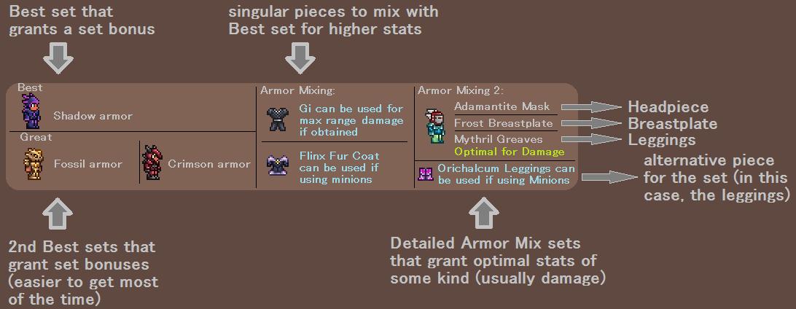  
  
+Weapons

-Weapons are the most crucial part of your build, so they have the most detail within the guide. They are split into 3 tiers, best, great, and good. (Once again, the weapons are ranked dependent on the boss effectiveness, not general crowd control use)  
-The weapon section is further split into **2 sides**, the left side is where the main weapons are listed for their rankings. While the right side has specialized listings depending on the class.

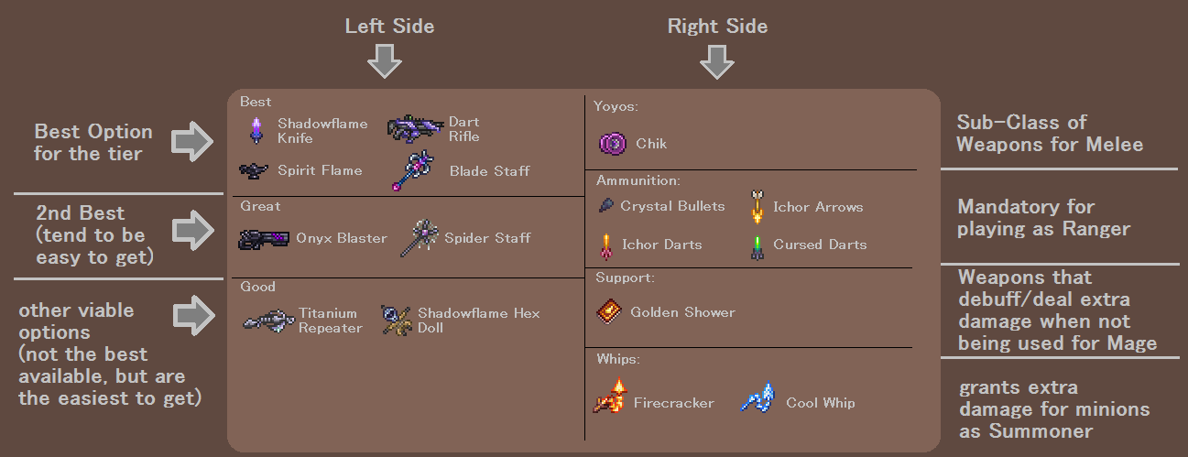  
**+For Melee:** Yoyos are listed, mainly to save space on the left side, and to utilize the empty space on the right side since Melee don’t have much to put there, they are ranked the same way that the left side is ranked (for example, if a Yoyo is listed in Great tier on the right side, that’s the equivalent of them being rank into Great tier on the left side).  
There is one exception for Melee, which is the Vampire Knives, they are a very effective tool for Survivability but also does quite well as a Main weapon

**+For Ranger:** Ammunition (ammo) is listed, they are required for a player to use most ranger weapons, so they’re very important. They’re split into 3 sub-categories, bullets (for guns), arrows (for bows and repeaters), and specialist (miscellaneous ammo). If a weapon only uses 1 type of ammo without any variation in that ammunition, then it is usually omitted to save space (ex. Stakes, Snowball, Candy Corn, etc.)

**+For Mage:** Support Weapons are listed, they usually serve 2 purposes, to inflict a debuff or leave a lingering projectile that deals damage without needing extra player input. For the debuff weapons, you utilize them by hitting the boss with the weapon to inflict the debuff, then switch to your weapon of choice from the left side to deal damage. Note that even if you’re not playing as a Mage, you can utilize these support weapons for extra damage or for inflicting the debuffs.

**+For Summoner:** Whips are listed, for a summoner, whips are as important as ammunition is for a ranger, they increase minion damage dealt on struck enemies, which contributes to a large part of a summoner user’s DPS  
  
**+Extra Notes**

-Some terminologies within the Guide:  
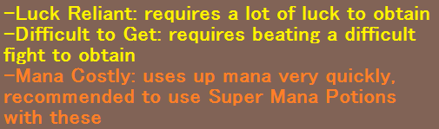  
+Mana Costly weapons are recommended to **not** be used with armor sets that don’t provide Mana Capacity boosts, as you won’t be able to take full advantage of Super Mana Potions to negate the high mana cost. Examples of such sets include: Crystal Assassin armor for Pre-Mech, the Tank sets for Pre-Plantera, and Beetle armor (Shell) in Post-Golem.  
Arcane modifiers on accessories can be used to remedy the issue, but that is usually not worth it outside of Nebula Blaze.  
+For explanations on what minion mixing and whip stacking are, check the [FAQ](https://docs.google.com/document/u/0/d/1QPXIp1F78LbPOND2B12bBTDx9GJwFLNJWX7yzYoZ9PY/edit).  
  
+Accessories   
-There are a lot of accessories that all are viable in their own rights in some way, so it is up to the player to decide how to specialize their build, but accessories for bosses will be split into   
**3 categories**, Movement, Damage, and Survivability.  
-**Movement** accessories contain accessories like Wings, extra jump Bottles/Balloons, and other miscellaneous tinkers that increase mobility in various methods. It is recommended to use these when not using a Mount as your main form of mobility. (you can also remove them if you are attempting some form of facetanking strategy)  
+**Boots** are a subcategory of movement accessories, they mainly increase ground movement but can be somewhat helpful in the air as well, they’re especially useful in Pre-Hardmode when you do not have access to good wings yet. However, in Hardmode, they become optional as a movement accessory, as you will be in the air for most of the boss fights.

-**Damage** Accessories will be where a large part of your boosts in DPS come from, there are a lot of them, and they can vary depending on how many you want to invest into your build, they are split into 2 tiers, similar to armors, best and great.  
-**Survivability** accessories are the alternative to damage accessories if you do not invest into those as much, they increase your longevity in a fight, and can help a lot for certain bosses (such as Star Veil/Cross Necklace for Destroyer), these are split into 2 or 3 tiers depending on the stage; best, great, and good.

-Among these, there are also **Expert+ accessories** that are only available in the higher difficulty levels, most of the ones mentioned mainly increase survivability and movement for the player.  
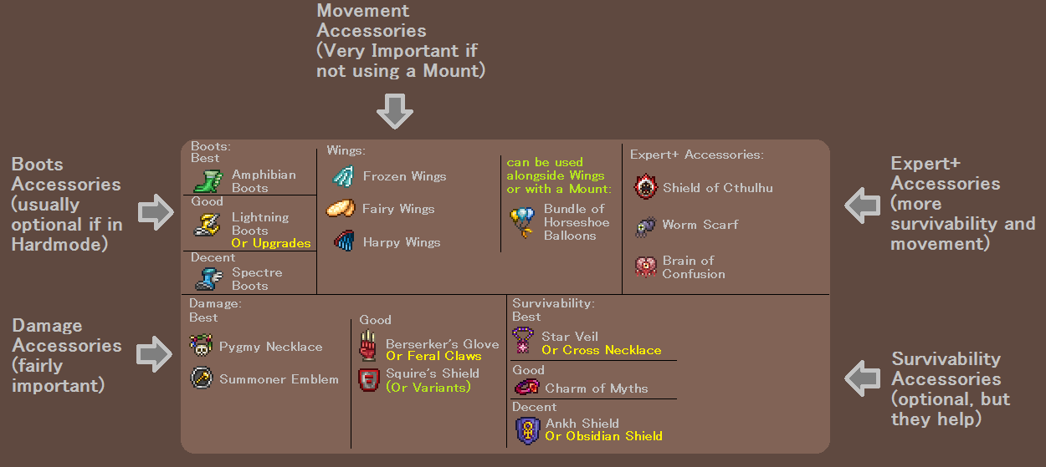

**+Hybrid and Tank Builds**

-**Hybrid** and **Tank** are subclasses of the 4 Main Classes, they basically take each of their respective specialty (Damage for Hybrid, and Survivability for Tank) and take them to the extreme.  
  
+Hybrid  
-Hybrid takes Summoner and combines it with any of the other 3 classes, utilizing minions + the other classes’ weapons for optimized damage and crowd control. This will require the hybrid user to specialize in armor and accessories that focus on both of the damage types, instead of just using one or the other.  
-Whipping can be incorporated into the Hybrid playstyle, if the player has the skill to weapon swap consistently, increasing the damage potential of minions even more.  
  
+Tank  
-Tank fully specializes in defense for maximized chances of surviving a boss fight, this does mean that the tank user is sacrificing damage to achieve this, but the pay off in survivability makes it a very effective strategy, this kind of build is not very recommended for doing events such as the Old One’s Army, or many such events that require you to have high damage to succeed.  
-**Tank for Pre-Hardmode** is not mentioned, due to the set up being just using full Warding reforges on the player’s accessories, and using the armor set that gives the most amount of defense for the respective class.  
  
**+Extra Notes**-for Pre-Mech, Queen Slime can be treated as if she’s included within the stage as well, since the gear recommended for her does not differ much compared to the Mechanical bosses, specifically weapons that are effective against the Twins and Skeletron Prime should also be considered for Queen Slime too. For the gear that is dropped by Queen Slime herself, they can just be perceived as not being there, as they don’t affect the rankings of the other weapons. 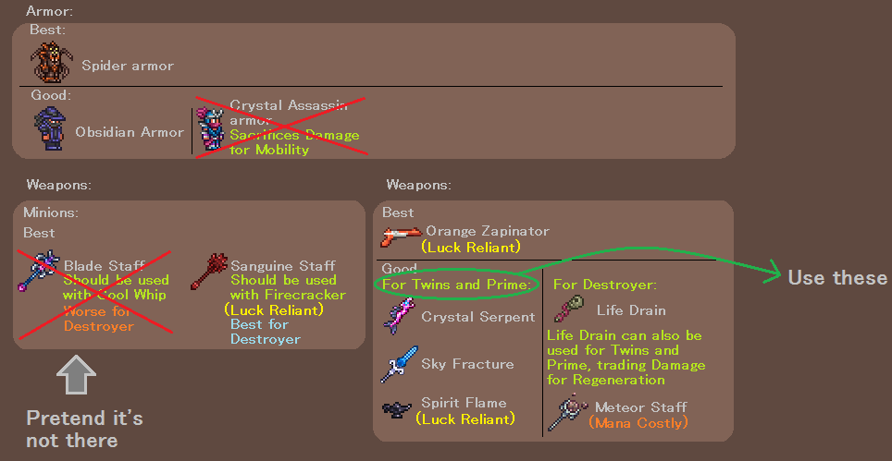-the Pumpkin Moon, Frost Moon, Duke Fishron and Empress of Light events and bosses are tiered at the Post-Golem tier, as to preserve the original progression intended by the developers + make progression for new players smoother.  
-this is due to Golem dropping a good amount of useful items that help for the events/bosses.  
Such as Destroyer Emblem, Celestial Shell materials, Stynger, and Staff of Earth.  
All while being considered easier than the events and bosses tiered after him by most people.  
-one exception to this would be Summoner users, who don’t benefit much from defeating Golem first, aside from possibly Celestial Shell. While benefiting much more from the Pumpkin Moon event, on top of the fact that they already have good crowd control. So, the Guide has given Summoners the decision of whether they want to do Golem or the Pumpkin Moon first.