**Some Notes about the Guide:**-the Guide is intended to be used alongside [the Official Wiki](https://terraria.wiki.gg/wiki/Terraria_Wiki), to look up how to obtain the gear suggested within the Guide.  
-the main folders are gear guides for those bosses, not general use for the stage.  
-the guide can be used for any difficulty, although some special seed exceptions might not always apply.

-the boss order is taken mostly from the wiki and developer statements, so gear will be suggested depending on that order.

-if you disagree with any of my placements then you can tell me through DMs or find me regularly on #Terraria-Help on the Official Discord then i could consider moving or adding something to the list.

**the 6 factors that weapons are ranked upon:**

-the weapons are based on how well they fare against the specific boss of the stage

-the average kill time on the specific boss

-how accurately can it hit and do consistent damage against that boss

-how does it compare to other options of the same stage  
-how safe is it to use while still doing good damage

-and by following other knowledgeable players opinions/guides

i.e:  
[Baconfry's In-depth Hardmode Weapons Tier List](https://forums.terraria.org/index.php?threads/in-depth-hardmode-weapon-tier-list.69834/)  
[Shyguymask's Summoner Guide](https://forums.terraria.org/index.php?threads/1-4-4-summoner-minion-whip-armor-in-depth-tier-list.105645/)  
[the Wiki’s Armor Progression Guide](https://terraria.wiki.gg/wiki/Guide:Armor_progression) (for armor)  
[Kepples’s Weapon DPS Guide](https://drive.google.com/drive/folders/1g-HbBtwLiBK38VPbj-tVcQUkHT9c0bbl) (for weapon rankings)  
-additional discussions about particular placements also take place within a dedicated guide discussion chat which include the people within this special thanks list

**Guide made by**

  
*"every little star has a reason to shine"*

  
*“bubble tea is serenity”*  
  
**For Managing the Pinned Copy on #Terraria-Help**

**Special Thanks:**

  
*“Also try Stardew”*  
  
Very consistent when it comes to giving suggestions, fixing the little details of the Guide. One of the first people to recognize and help the development of the Guide. Also made many external contributions such as helping the Guide get Pinned on the Terraria-Help Channel and getting it linked on the Class Setups Page on the Official Terraria Wiki.  
  
cool but underwhelming.  
  
Notable Works: [badname’s Wiki Class Setups Guide](https://terraria.wiki.gg/wiki/User:Damnthisisabadname) (in collaboration with: tewu_, jon.5 and zahryz)  
  
  
  
  
*“Flem  
The guide is absolutely f*cking awesome and has helped with Terraria gear advice and information sharing so much and it’s seriously underrated and you should be f*cking proud of it if you aren’t”*  
The most consistent person when it comes to sharing the Guide to other people on the Discord, also is very Wholesome when talking about the Guide, a funny person.   
  
Notable Works: [Ender’s Terraria-Help Image Collection](https://drive.google.com/drive/folders/133cwCHs7phfw5mvWKUc5mddzWfJXrsVG)

  
*"as a rule of thumb, each point of defense is more effective than a 1% DPS boost when damage taken per hit is less than 50 classic / 75 expert / 100 master.*[*"*](https://drive.google.com/drive/folders/1jqlB6aeRSRDc7cSkV7DXpW7tDqf7Aklg)  
  
Has helped MASSIVELY with giving suggestions on the Tank Builds and Events part of the Guide and the main reason they even exist. Also helped a lot with weapon suggestions, mainly for Melee and other miscellaneous suggestions related to the Progression Pages.  
Definitely the most impactful person on the development of the Guide.  
  
Notable Works: [CJ's Support Codex](https://drive.google.com/drive/folders/1jqlB6aeRSRDc7cSkV7DXpW7tDqf7Aklg) and [CJ’s Useful Links](https://docs.google.com/document/d/12z6RdAEV75uvxs_a9E4PKDM2Aw4kux6FNGWAtiD2Q3Q/edithttps://docs.google.com/document/d/12z6RdAEV75uvxs_a9E4PKDM2Aw4kux6FNGWAtiD2Q3Q/edit)

  
*"mushroom spear is the best spear in the game (trust me)"*  
  
Very consistent in both sharing and giving suggestions to the Guide. Is a big reason the Progression Guides exist, and has helped with spotting a lot of Typos, and has very positive vibes. He will be Back.  
  
  
  
  
Helped with spotting Typos in the Guide, contributed to a bunch of Summoner related changes.  
  
Notable Works: [Bloodzy's Summoner Guide](https://docs.google.com/spreadsheets/d/1F0lxQ3M3KRx3s4Kg6n3MzhnQsqEWSy5uTf36VQByjp8/edit)

  
*"if you want to make something, look it up and throw everything together, if it doesn't work, isolate the problem, remake it, repeat until it does"*

Or as i like to call him, “Hoik Man”  
Though in all seriousness his real name is Quasar, ARK is his Smash Team.  
Has been very positive about the Guide and consistently shares it in Terraria-Help.  
And provides most of the hoik related stuff within the guide.  
  
Notable Works: [Quasar's Advanced Hoik Guide](https://drive.google.com/drive/folders/1V3B0beo4F5M5X5FvNIA04i13eTlsXKif?usp=share_link)

  
*"Mobile is not an increase to difficulty"*  
  
The Piggy.  
My Emotional Support. Has been consistent with sharing the Guide, with a few suggestions and typo mistakes.  
A message from another Pig: *Use Golf Cart.*  
  
  
Notable Works: [Defender's Mobile Guide](https://drive.google.com/drive/folders/1zbmrExl7emCNEuTX3AmuPDyN8X_kldOB)

  
*“crawnbrry”*  
  
You may know him from his Youtube, the Humble Femboy himself, Sorbet Cafe, has fixed a lot of errors about details that I otherwise miss as I'm not as experienced, like Cultist being immune to all Debuffs and Molten Quiver only affecting Wooden Arrows. Alongside that, has helped with certain progression placements for bosses and events.

Also has helped a lot with weapon suggestions, mainly for Ranger

Notable Works:   
[The Best Possible AFK Money Farm in Terraria](https://www.youtube.com/watch?v=w5IGOkifk0o&t=25s)   
in collaboration with:  
dinochess14 and quasar128   
  
[How to cheese EVERY boss in Terraria](https://www.youtube.com/watch?v=jPxF_SVZ9kY&t=777s)  
  
  
  
  
*"my flamarang throwing skills are unrivaled"*  
  
Has given a good amount of suggestions to the Guide both gear and design wise, and his DPS tests on weapons have given me insight on some weapons i would’ve neglected and confirmed some that i wasn’t 100% sure of  
  
Notable Works: [Kepples’s Weapon DPS Guide](https://drive.google.com/drive/folders/1g-HbBtwLiBK38VPbj-tVcQUkHT9c0bbl)  
  
  
  
  
*“Unfortunately, this is not possible due to the limitations of time and space”*Very Consistent in sharing the individual pages for people asking for help on the Discord, and has made a good amount of suggestions relating to gear  
  
  
  
  
*"you lost the game"*Has Given many suggestions for Gear related stuff, including but not limited to Tank, Weapons and Armor.  
Also has helped fix MANY Typos within the Guide, being the Strategies and Buffs Guide, FAQ, and many other pages  
  
Notable Works: [Tewu’s Armor Mixing Guide](https://docs.google.com/spreadsheets/d/1_s6ekdkZRcgsS4owHP9dzwp5UuQ2pBczQJm7wTgfURk/edit?usp=share_link)and [Tewu’s Wiki Class Setups Guide](https://terraria.wiki.gg/wiki/User:TeWu/Class_Setups)(in collaboration with: thisisabadname, jon.5 and zahryz)  
  
  
  
*"The problem with being faster than light is I always have to live in darkness"*  
  
Has contributed much to the development of the Guide in terms of visual improvements, along with many gear and wording related decisions  
  
Notable Works: [Yousef's World and Character Recovery Guide](https://docs.google.com/document/d/1OCh7Gkr4rO3vRaT11DJJ3pAR6XgYfExZhJdxhlTARHE)  
  
  
  
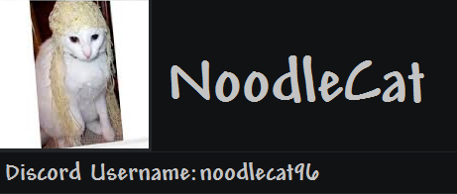  
Helped with specific knowledge about more obscure subjects about classes to improve min maxing (such as Ichor Arrows on Phantasm, and Mana Regeneration Potion on Demon Scythe) and general DPS calculations  
  
Notable Works: 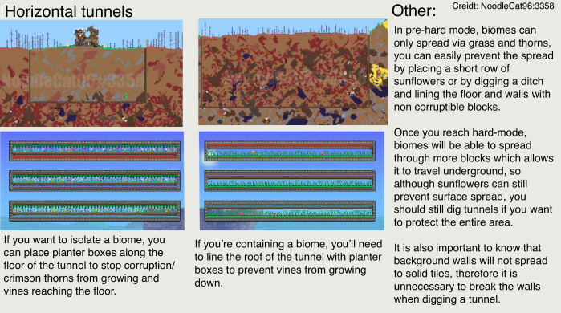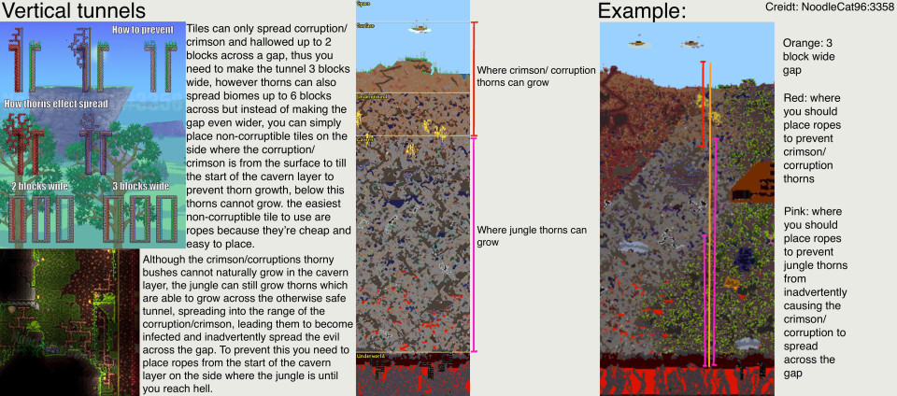  
  
  
  
  
*"All this weapon talk confuses me, i just follow jason's guide"*Helps in many obscure parts of the guide, stuff that are easily missable like info notes or category text, along with some minor gear suggestions.  
  
  
*“play neko atsume”*Very consistent at suggesting things related to gear, more niche details like sentries for Pre-Beerclops and Spider Staff’s performance with Optic Staff against Plantera.  
  
  
*“play Etrian Odyssey”*Highly knowledgeable and helps consistently with gear related changes and suggestions, more specific things relating to DPS calculations and weapon interactions with accessories and stats.  
  
  
Very consistent at giving suggestions to certain gear changes (mostly accessory related), either through the dedicated guide discussion chat or on #terraria-help, is generally a very kind and helpful person while on the help channel.  
  
  
*"play rhythm heaven"*  
  
Gives consistent gear related suggestions to the guide, mostly within the guide discussion chat, is a knowledgable and dedicated member within the Official Terraria Discord.   
  
Special Thanks to the people who regularly share the Guide:  
- **backfloop  
- snah745   
- jon.5  
- thatspacemelonloveshestu  
- james1328  
- jaffiiii  
- ns0_7x**

**- localshowershitter1199**