External Tactics
The Hoik Invincibility Machine:
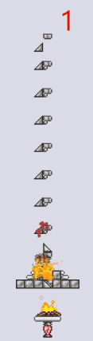
This machine utilizes hoiks to push you up and down to take fall damage at the perfect timings, allowing you to ignore almost every attack in the game very reliably.
Note: remove any accessories that change fall damage (Wings, Horseshoe, Frog Leg) and Inner Tube if using honey within the contraption, this machine does not work for Moon Lord, Empress of Light and Wall of Flesh.
Minimum Defense Requirement:
Classic Mode: 17
Expert Mode: 11
Master Mode: 9
You also need at least 3 health regeneration per second to sustain it indefinitely, though this isn’t too difficult to achieve with a Heart Lantern, Campfire, Band of Regeneration and Honey
Tutorial on Hoik Invincibility Machine (Definitive Version of the Machine)
Voiced explanation on the Hoik Invincibility Machine (Definitive Version)
These Links are here for Archive Purposes, there’s not much point to use the designs in these older videos:
-Tutorial on Hoik Invincibility Machine for PC (Version 1 and 2 of the Machine) (can be watched if you want a voiced explanation about how the Machine works)
-Tutorial on Hoik Invincibility Machine for All Platforms (Version 3 of the Machine)

Full credit on the designs go to quasar128 on Discord (the Original Thread’s Link about the Machine)

Sorbet Videos:
How to Cheese Every Boss:
How to cheese EVERY boss in Terraria
*note: Queen Slime and King Slime’s cheese are outdated, check the Strategies document for the updated strategy
How to Get into the Dungeon before Killing Skeletron:
How to loot the dungeon without killing Skeletron
Comprehensive Guides:
The Comprehensive Guide to Mining
The Comprehensive Guide to Hoiks
The Comprehensive Guide to Defense (Terraria)
How good is the lucky reforge?
CJ’s Support Codex and Useful Links:
CJ's Support Codex
A collection of many frequently asked questions and tech support answers packaged together for easy use.
Useful Links
A collection of many useful links for resources that are useful for intermediate to advanced level terraria players, some already listed here, some not.
Kuz’s Terraria Community Archive:
Kuz’s Community Archive
A website that contains links to many different resources related to Terraria, either be user-made guides (some of which are already listed here), and third party programs such as map viewers and world editors.
Kepples’s Weapons DPS Tests:
Kepples's Weapon DPS Guide
A document archiving kill time tests for many weapons against all the bosses in the game.
Patrik2569’s Advanced Terraria Strategies:
Advanced Terraria Strats
A collection of many more obscure and advanced Terraria strategies, some used in speedruns, some to make gameplay easier.
Quasar’s Advanced Hoik Guide:
Quasar's hoik guide
A guide which aims to teach the next level of hoik knowledge to players who are interested (recommended to read the wiki page about hoiks first before reading the Guide)
Another Hoik Guide by Quasar in collaboration with Sorbet Cafe: The Comprehensive Guide to Hoiks
Dinochess’s NPC Spawning Guide:
NPC spawning
A guide which aims to explain to the players about the mechanics and details of how enemy spawning works.
badname’s and TeWu’s Class Setups:
badname's class setups
TeWu's class setups
More compact and simplified Class Setups Guides on the wiki which also have accurate info.
TeWu’s Armor Mixing Guide:
TeWu's armor mixing sheet
A guide that aims to teach the players more about experimenting with armor mixing, other than just the ones recommended in this Guide.
Bloodzy’s Summoner Guide:
1.4.4 Summoner Setup Guide
A guide which has suggestions for gear on Summoner (mainly damage focused)
Shyguymask’s Summoner Tier List:
Shyguymask's Summoner Tier List
An in-depth tier list that aims to note all the details on Summoner weapons and armor
Baconfry’s Armor Chart:
Baconfry's Armor Chart
A full chart containing all possible viable armor sets and armor mixes, providing their stats distribution and effects
Also available on: Armor Progression
Pig’s Hardcore Guide:
Pig's Hardcore Guide (WIP)
A guide for Hardcore mode, teaches tips and tricks to stay alive longer.
Yousef’s World Corruption Recovery Guide:
World/Character Recovery Guide
A guide for recovering corrupted worlds on PC.
Ender’s Help Image Collection:
Ender’s Terraria-Help Image Collection
A collection of useful images to be used on Discord or other platforms.
Defender’s Mobile Controls Guide:
Defender’s Mobile Guide
A guide to help mobile players get more familiarized with touch screen controls.
qwerty3.14’s Mana Guide
qwerty3.14’s Mana Guide
A post explaining the details of Mana and how it affects your damage. Certain details might be outdated as of 1.4.4 but the general concept should still be valid.
Detailed explanation on Terra Blade’s interaction with Melee Speed:
The Terra Blade, 104% melee speed, and why Violent is sometimes completely useless
Bame’s Lesser Known Uses for Certain Items:
Lesser Known Uses for Certain Items
A collection of more obscure strategies that didn’t fit into the format of this guide.
Catt’s Modded Recommendations:
bingus.txt | A comprehensive mod list
A collection of mods that are recommended for newer players wanting to try tmodloader.
How to Find the Aether:
Guide to Finding the Aether (Shimmer)
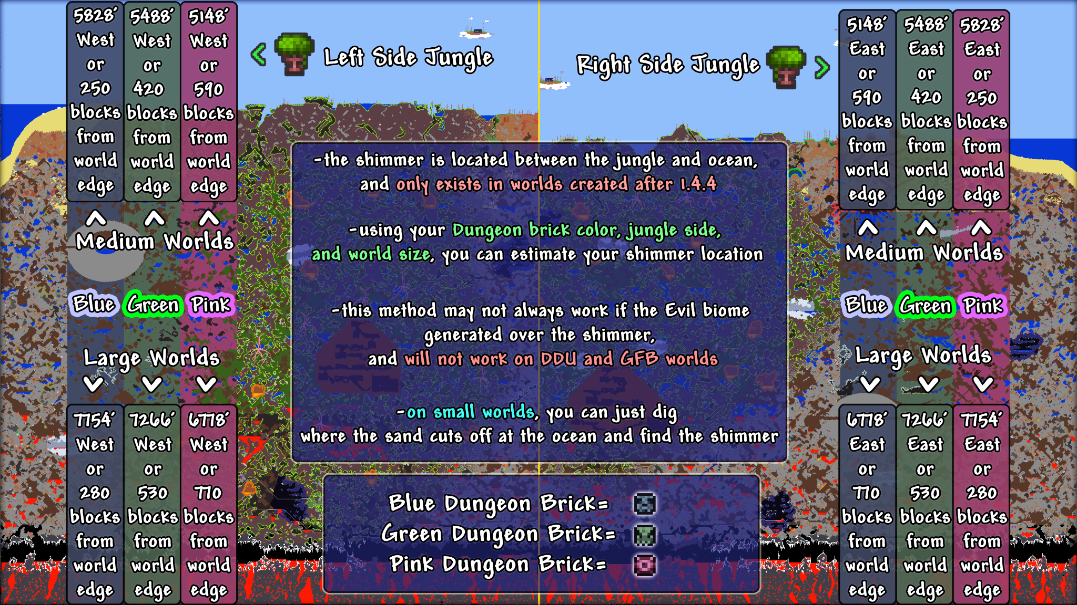
Mana and Heart from Statue enemies:
Aside from Heart and Star statues giving their respective drops, enemy statues can be used to achieve the same thing. However only certain enemies that don’t have their drop rate reduced should be used to get the most efficiency, those being: Slime, Wall Creeper, Crab and Armed Zombie.
Something like a Nimbus Rod or Clinger Staff can be used to kill the enemies, and will make the enemies accumulate mana stars or hearts depending if you’re missing health or are consuming mana.
