Secret Seed Tips and Strategies
this document is for tips and strategies related to the secret seeds of Terraria, if you are looking for tips and strategies that apply to all seeds, refer to:Tips and Strategies
1-GEAR CHANGES
2-BOSS TIPS
-BRAIN OF CTHULHU
-EATER OF WORLDS
-SKELETRON
-WALL OF FLESH
-MECHDUSA
-MECHANICAL BOSSES
-PLANTERA
-GOLEM
-MOON LORD
Basic Terminology:
-Secret world seeds are world seeds which contain changes that generate worlds with strange and unique features.
The following is a list of all the secret world seeds and their main characteristics:

+Drunk World (5162020): many minor and major changes to world generation such as giving both world evil and the dungeon being under a living tree with brown painted leaves

+Not the bees: changes the entire world into a Hive and Jungle invested environment

+For the worthy: adds an abundance of changes to make the game harder, both to the environment and enemies/bosses. This seed also makes whichever difficulty you selected to create the world be increased by 1, so for example, if you selected Classic Mode, the world will be listed as Expert Mode. If Master Mode is selected, then the world will be Legendary Mode.

+Celebrationmk10: adds a variety of cosmetic and gameplay changes to make the game easier and more festive, such as starting with multiple Hardmode NPCs, and higher chances to obtain certain items.

+The Constant: makes the Don’t Starve crossover related items easier to obtain, and adds a filter and a Hunger Mechanic.

+No traps: generates the world with significantly more traps, alongside adding some new traps

+Don’t dig up: basically flips the world upside down, the world spawn is in the Underworld, and the Surface is infested with monsters and the mechanics of NPC happiness and nighttime is mostly removed.

+Get fixed boi: combines all the above seeds features and adds some extra mechanics to make the game even more annoying/harder. All tips that apply to a certain secret seed will also apply to Get fixed boi.
1-Gear Changes
-the Don’t dig up and Get fixed boi seeds contain changes to obtainability and stats of certain weapons, effectively swapping their tier of progression, this specific section will focus on the notable ones, including some added changes and gear to Drunk World and Celebrationmk10
For weapon recommendations on Mechdusa, check the Boss Tips section.
As another note, Star Cannon (and by extension, Super Star Shooter) have their projectiles reflected by most bosses on For the worthy/Get fixed boi, so it is not recommended to be used at all on those seeds, aside for maybe crowd control purposes.
DDU changes
Pre-Hardmode
+Magic Dagger in Pre-Hardmode
-It swaps with Wand of Sparking/Frosting in progression, and is an upgrade in every way, the damage output is now on the same tier as Diamond Staff, with range and projectile velocity being not as much of an issue as before.
This does mean however that Wand of Sparking/Frosting in Hardmode is weaker than the normal Magic Dagger.
+Ice Bow in Pre-Hardmode
-is comparable to a Demon Bow/Tendon Bow in single target damage, whilst being much easier to aim.

+Unholy Trident in Pre-Hardmode
-is higher single target damage than Demon Scythe, but piercing isn’t as high, if you don’t get blocked by the hungries that much, this is an excellent choice against the Wall of Flesh.
Hardmode
+Flower of Fire in Hardmode
-is higher single target damage than Venom Staff. In a way, it is comparable to Shadowflame Hex Doll, very high damage but isn’t the safest to use, the projectile being affected by gravity and non-piercing makes it so that you have to be close up if you want to use it effectively against Plantera.

+Katana in Hardmode
-is a massive upgrade compared to normal Keybrand, its single target damage is so high that it actually rivals Starlight. It is most effective against Golem if facetanking.
+Aqua Scepter in Hardmode
-single target damage is now comparable, and at times, exceeds that of Nebula Blaze, it’s basically normal Bubble Gun without the range drawback. If you obtain this in Early Hardmode, it will trivialize most of the bosses, even in Get fixed boi.
However this does mean that Bubble Gun in Pre-Hardmode isn’t as impressive, for the Wall of Flesh fight, the Hungries blocks its projectiles a lot, and it doesn’t have any notable crowd control uses.
Drunk World addition
+Moon Lord Legs
-A legging armor item that gives boosts to mobility, it is comparable to a Frog Leg for its boosts to jumping. This works well with any armor combinations that don’t rely much on a specific set bonus from wearing the leggings as well, such examples include the Flinx Fur Coat and the Gem Robes
Celebrationmk10 changes
+Wizard Hat giving a minion slot
-Wizard Hat gives a minion slot on the Celebrationmk10 (and by extension, Get fixed boi) seeds which combos very well with the above mentioned scenarios, and can also be combined with Moon Lord Legs, a set such as Wizard Hat + Flinx Fur Coat + Moon Lord Legs is a phenomenal Early Pre-Hardmode Summoner hybrid mix that many other sets will struggle to match
2-Boss Tips
This section will provide tips that relate to the changes brought about by For the worthy and Get fixed boi, if you are looking for general boss tips that apply to all seeds, refer to the Strategies document
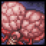
BRAIN OF CTHULHU
-with the way Brain of Cthulhu flips gravity during its 2nd phase, it will be difficult to dodge if you fight it unprepared, an easy way to deal with the flipped gravity is to limit the positions of where Brain of Cthulhu is able to spawn, as it can’t appear itself inside of blocks, you can manipulate it into one position and use a high knockback weapon to make the second phase as safe as possible, this method also works on regular seeds, but usually isn’t needed, below are some examples:
Video example: Foolproof way to defeat Legendary BoC
Note: Any solid block can be used, it does not need to be specifically Crimstone.
The minimal setup, only the blocks in the corner matter, with the player hooked in the center
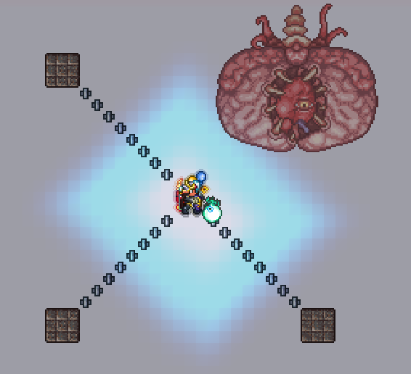

EATER OF WORLDS
-Eater of Worlds on For the worthy and Get fixed boi is generally considered one of the hardest bosses in the game, due to most of its attacks being considered contact damage, which is boosted in For the worthy.
Facetanking strategies will not work, and you may be inclined to use some Cheese Strategies
Otherwise, the best you can hope for is to make a big underground arena, as on the surface, the vile spits can not be destroyed.
Skipping this boss temporarily and attempting other bosses first is a viable strategy.

SKELETRON
-Skeletron on For the worthy and Get fixed boi will spawn Dark Casters that shoot indestructable water bolts during the fight after his hands are destroyed, however those Dark Casters will not be able to shoot temporarily if they are hit, so using weapons that can help mitigate the amount that they are able to shoot can help quite a lot.
Some examples of such weapons are: most sentries, bee weapons, minions, or even Inferno Potions if you don’t mind the extra visual clutter.
A more preparation intensive strategy is by using lava to prevent spawns + Minecart Tracks as spots to hook to.
The Dark Casters require regular blocks or platforms to actually spawn on, covering the bottom of your arena with lava will prevent a majority of them from spawning.
After that, instead of platforms, you can use Minecart Tracks arranged similarly to platform layers in a normal arena, you can’t stand on them, but you can hook to them, this can be combined with a Featherfall Potion to give you the mobility necessary to beat the boss without having to deal with the Dark Casters.
Video example: GetFixedBoi Legendary Hardcore Skeletron (the arena does not to be this big, but it does help)
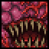
WALL OF FLESH
-Wall of Flesh on For the worthy and Get fixed boi is also a very difficult boss, one of the simplest ways to make the fight easier is by putting Fire Imp banners throughout your arena, you can get the banners easily if you have an Imp Statue. It will significantly reduce the amount of damage you receive from the fight, as the fireballs from them are counted as contact damage, which is boosted by For the worthy.
The strategies used to dodge Wall of Flesh’s lasers in regular seeds will not apply, as the Fire Imps will spawn in your way, making you have to jump to dodge.
-one of the specific strategies available is a combinations of exploits of Wall of Flesh’s attacks
The eyes can not shoot their lasers if they do not have a line of sight with the player, so blocks are placed in to stop them.
A Railroad track is used as mobility, and in places where Fire Imps will spawn, Dart Traps are used in intervals, as the Imps can not shoot their Fireballs for awhile after they are hit, for a video example of the instructions, refer to: How to NO HIT DESTROY Wall of flesh on Getfixedboi Legendary Hardcore - Terraria Zenith
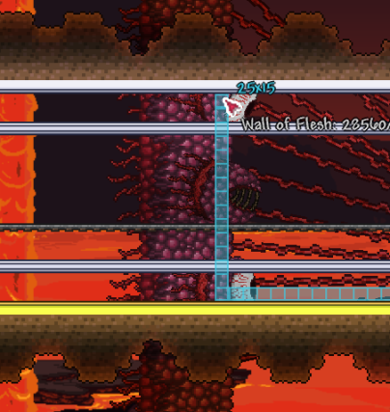
Due to Mechdusa being mostly different than just fighting the regular Mechanical bosses, it will be treated similarly to a new boss:

MECHDUSA
Arena: you can either fight it on the True Surface, using a long bridge, filled with a thin layer of lava to completely stop enemy spawns (use an Obsidian Skin Potion, Water Walking Potion or Terraspark Boots to be able to walk on the lava), the bridge can be made out of sand if you have Dunerider, to utilize the extra speed.
the alternative is digging out a large area in the Underworld, to not have to deal with the low gravity, and have rows of platforms with 2 to 3 layers, spaced far apart, with Teleporters hooked up to each end of the Arena, this will allow you to be able to circle around Mechdusa without needing to actually circle it.
Tips: this is a very long endurance fight with you having to kill all 3 Mechanical Bosses at once. Though that is only required for advancing to Plantera, you can kill one of these Mechs individually when fighting Mechdusa to get their Treasure Bag, giving access to Hallowed Bars and their other loot, this is advised if you struggle to kill alll 3 the first time fighting it.
the recommended order to kill the parts is: Destroyer first, Retinazer second if you have good enough defense to tank his lasers, Spazmatism second if not, and Skeletron Prime last. Skeletron Prime should always be killed last due to him being the part that holds the other 2 Mech bosses together, if he dies first, it will make the fight harder
Gear: highly recommended to use a Tank Build due to there being no time limit on the fight, it will help a lot for taking many hits from the projectiles since they don’t scale with For the worthy’s damage multiplier, and make contact damage not nearly as deadly.
Mounts:
 Winged Slime: balanced horizontal and vertical mobility, can also be used for faster downwards descent
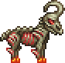
Unicorn & Goat: can be used to quickly gain distance
The following Mounts are best used with Bundle of Horseshoe Balloons:
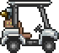 Golf Cart: amazing mobility both acceleration and speed wise, has long invincibility frames after ramming
 Basilisk: amazing mobility both acceleration and speed wise, has an extra jump
Wolf: better acceleration and speed than both Golf Cart and Basilisk
Additionally, here are weapon recommendations against Mechdusa if you do not have Duke Fishron weapons:
Link to image
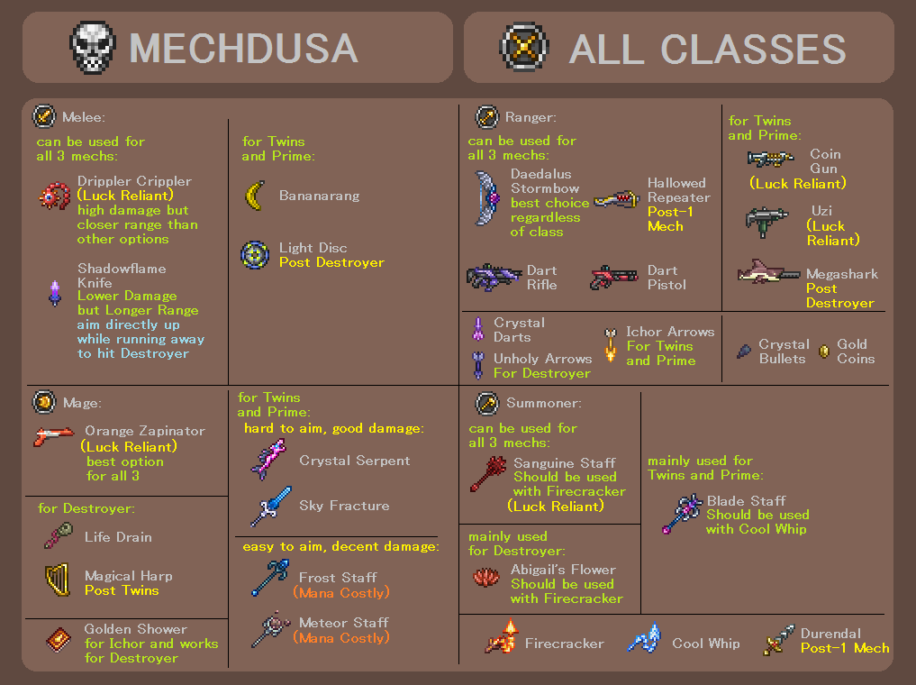
You’ll likely want to use different weapons for Destroyer and Twins/Skeletron Prime segments specifically, as to maximize damage outputs between the stages of the boss. Although some weapons will perform well for all three.
If you don’t care about classes, the most recommended options include: Daedalus Stormbow with Unholy Arrows and Ichor Arrows, Dart Rifle with Crystal Darts, and Orange Zapinator.

Obviously, if you have access to Duke Fishron weapons, those will eclipse any of the weapons mentioned here, especially Aqua Scepter.

MECHANICAL BOSSES (FOR THE WORTHY)
-For Skeletron Prime: do not fight him anywhere that you want to preserve intact, as his bomb cannon will destroy blocks and platforms vulnerable to explosives.
One of the easiest ways to counter this is to use blocks that don’t get blown up by explosives, such as Dungeon Bricks, or Hardmode Ores such as Cobalt or Palladium.
*Note: if you are using Dungeon Bricks, do not break the floor of the dungeon entrance, as it can mess with the spawning of the Cultists later on, making them not spawn.

-For The Destroyer: due to having many more segments compared to regular seeds, it is actually easier to kill him on For the worthy with high/infinite piercing weapons, some examples include: Hellwing Bow with Wooden Arrows, Sandgun with Ebonsand/Crimsand, Dao of Pow and Life Drain.

PLANTERA
-Plantera’s contact damage is not increased in For the worthy/Get fixed boi, making the usual strategy of facetanking her with weapons such as Fetid Baghnakhs and Drippler Crippler just as effective as they are in regular difficulties. Keep in mind however that her Tentacle’s contact damage are still increased.


GOLEM
-Golem in For the worthy/Get fixed boi will hinder the player’s vision and has a much faster movement speed than in regular difficulties.
For vision, one possible solution is to use Illuminant Coated Gemspark Walls, such as in the example below:
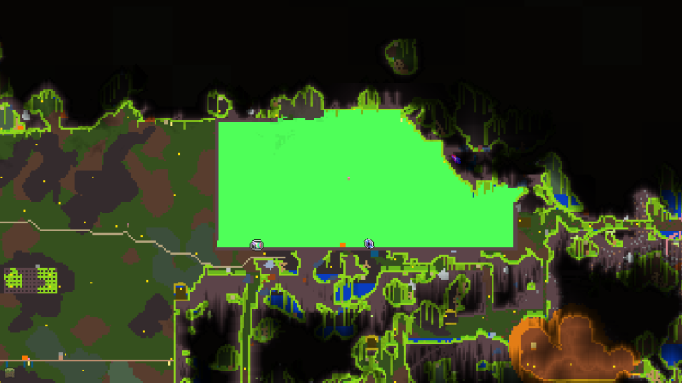
This does require you to learn how to lure Golem outside the Temple to fight, the methods of which are in the regular Strategy Guide
-Using bright colored walls with Illuminant Coating also work, although results for those will vary.

-as mentioned above, luring Golem outside is a viable strategy here, as it makes his fast movement and small hitbox easier to deal with, but if you are adamant about fighting him inside the Temple, filling the Golem Room with honey is a possible strategy, as it will reduce Golem’s movement speed. But comes at the cost of visibility, as honey is not translucent.

MOON LORD
-in Get fixed boi, the only change that Moon Lord receives is getting an additional “Moon Boulder” attack, it will always activate after the forehead eye’s Phantasmal Deathray, so the main strategies to dodge it include:
+using a recall potion to get away from it
+don’t be near areas with blocks on the ground, as the Boulders can, and will bounce up again to hit you.
+be far enough away to mitigate the chances of being hit
+An alternative method is to time when the Moon Boulders will appear, and lure Moon Lord’s top eye into a box/celling to trap the Moon Boulders, rendering them harmless to the player, this method is a bit more precise to perform but works well for arenas made in the Underworld, where a celling already prepared.
-other than that, Moon Lord himself in For the worthy/Get fixed boi gets no boosts to attack damage, allowing Tank Builds to be quite effective for this fight.
-although, True Eyes of Cthulhu do have their contact damage boosted, this mostly matters if you are facetanking, as it can quickly kill NPCs such as the Nurse, if you are using such a strategy.

