Tips and Strategies
Pre-Hardmode Bosses:
-EYE OF CTHULHU & KING SLIME
-EATER OF WORLDS & BRAIN OF CTHULHU
-QUEEN BEE & DEERCLOPS
-SKELETRON
-WALL OF FLESH
Hardmode Bosses:
-DREADNAUTILUS
-QUEEN SLIME
-MECHANICAL BOSSES
-PLANTERA
-GOLEM
-DUKE FISHRON & EMPRESS OF LIGHT
-DUKE FISHRON (PRE-MECH) & EMPRESS OF LIGHT (DAYTIME)
-LUNATIC CULTIST
-MOON LORD
Events:
-GOBLIN ARMY & PIRATE INVASION
-PUMPKIN MOON & FROST MOON
-MARTIAN MADNESS
-OLD ONE’S ARMY
-CELESTIAL PILLARS
BOSS STRATEGIES

EYE OF CTHULHU & KING SLIME
Arena: a long one about 100 to 200 blocks long, can be made of platforms or be a flattened out surface
Tips: for both of these bosses, the main strategy is just trying to run in 1 direction until you
need to turn around, hence the need for a long arena, Hermes Boots or one of its variants is
recommended before you attempt these bosses, especially in Expert+ Difficulty
King Slime can be mostly avoided by dropping down the platform version of the arena when he's
on it, this will make him drop down below the arena, away from you, and you can use a long
ranged weapon to hit him, repeat the steps when he teleports back up
a piercing weapon can be used to deal with the Servants and Slimes while still using a main weapon for Damage on King Slime and Eye of Cthulhu
Specific Startegies: by building a platform elevated above the ground and placing blocks above the platform, with a platform in between the blocks, with the right block hammered 2 times you can stand in between the platform and the unhammered block by clipping into it with an extra layer of platform on top of the original one through holding up while in the middle of the extra layer
by doing all this, King Slime will be unable to ever hit you, and will make the fight have no pressure
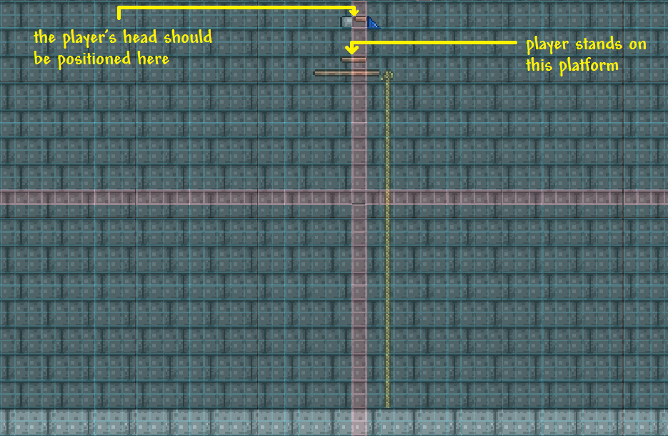
Video Example:
The Comprehensive Guide to Hoiks
An alternative design:
Youtube
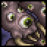
EATER OF WORLDS & BRAIN OF CTHULHU
Arena: multiple platforms layers, 50 to 100 blocks long on the surface or in the Corruption Cavern/Crimson Caverns
In Expert+ mode, due to the Eater of Worlds mechanic of becoming more aggressive on the surface. Arenas built on the surface have the advantage of more open space to dodge, but they come at the cost of increased movement and attack speed from the boss.
Tips: for both bosses, a piercing weapon is highly recommended, as they both have many
targets and will require something that can hit multiple entities
For Eater of Worlds, on lower difficulties, it doesn't deal too much damage with its body
segments, so facetanking it is a viable strategy if you have good defense, also try to avoid the head if possible
For Brain of Cthulhu, its first phase requires a piercing weapon, but for phase 2, there's only 1
target so something with high knockback is recommended, for the silhouettes that it creates in
this phase, you can use some type of debuff like On Fire! to make the real one more
visible, a Whip can also work for the Minion Targeting Circle
Specific Strategies:
by making a minecart track with both ends hammered 2 times and a few
survivability potions: Endurance, Ironskin, Regeneration, Exquisitely Stuffed, a Heart Lantern
and a Campfire, you can reach max speed on the Minecart track and summon Eater of Worlds,
the Minecart will destroy any segment that comes to touch you, shredding him. While the hearts dropped by those segments help you stay alive. A Heartreach Potion can be used to collect the hearts easier, so use it if obtained.
Note: this strategy will be much less effective or straight up not work on For The Worthy and Getfixedboi worlds due to the increased contact damage.
The minecart strategy also works for Brain of Cthulhu’s Creepers although the 2nd phase will give you trouble if you are on For The Worthy or Getfixedboi (check the Secret Seed tips and strategies document for dealing with the 2nd phase, to combine both strategies)
Example Videos: Original or Youtube
A Eater of Worlds specific strategy is using boulders to kill him, by building up 50 blocks into the air, creating an artificial Corruption biome, and stacking multiple boulders on top of each other on the spot it will spawn, the Eater of Worlds will be defeated seconds after it is summoned.
Example Video: Youtube (recommended to watch this first if using this strategy)
Mounts:
 Slime: effective for Eater of Worlds, to be used to bounce on it.

QUEEN BEE & DEERCLOPS
Arena: For Queen Bee: the arena can be made inside the Hive or made anywhere inside the Underground Jungle, multiple layers of platforms should be used, but they should be spaced about 10 to 20 blocks away for each layer, and each layer should be around the Width of the Hive, or around 50 to 100 blocks long
The arena shouldn’t be made on the surface or anywhere outside the Underground Jungle as she will enrage and become much more aggressive.
For Deerclops: an arena is completely optional, but if one is made, it should be a platform elevated about 20 to 25 blocks above the ground
Tips:
For Queen Bee:it is recommended that you have good mobility for the fight, mostly vertical mobility. When she's shooting stingers, you can run back and forth, jump at the end before turning around to create a path for you to turn, alternatively, hiding behind blocks also works due to the stingers not being able to pass through blocks. Have a piercing weapon ready for when she's overwhelming you with bees, and focus on doing damage when she's standing still to spawn those bees, as for her most prominent attack, her dashes. It can be dodged with a variety of ways: just jumping, using the Slimy Saddle to get better velocity ascending and descending or if on Expert+ Difficulty: using the Shield of Cthulhu to dash into her when she dashes into you
For Deerclops: constantly switch sides whenever she does an attack, this can be done by jumping over her, using the platform to run back and forth, or going between her legs, since they don't have a hit box, you can just run right through.She is invulnerable when you are further than 30 blocks from her, so fighting from far away isn't an option. But she also does not despawn when you die, but rather when 24 minutes have passed after her spawning, so you can throw yourself at her as many times as you like, even if you do die a couple times.
Mounts:
Slime: can be used for easier dodging against Queen Bee’s dashes.
Pogo Stick: similar to Slimy Saddle.

SKELETRON
Arena: multiple layers of platforms (2 to 3 layers) that are 100 to 300 blocks long, can be built on top of the Dungeon
Tips: the main strategy is just trying to dodge the hands and circle around his Skull when he spins, if you get hit by his Skull, you'll most likely get stunlocked and repeatedly get hit, if you do, try not to panic.
There are 3 ways to get out of the stunlock, either using a Hook to pull yourself out, using an extra jump like the Blizzard in a Bottle to boost yourself out, or use the Slimy Saddle to bounce out. Other than that, just repeatedly circle in both phase 1 and phase 2 and you should be able to get through the fight, in Expert Mode+, focus on destroying his hands first, as they give his skull higher defese. Just continue circling his skull while avoiding his projectiles for the rest of the fight.
Skeletron also tries to catch up to the player by rasing his speed if they are too far away, making his contact attacks harder to react to, due to this, it is advised to keep Skeletron’s skull mostly on screen.
Finally, when only his skull is left, it is possible to keep an internal clock on when Skeletron will switch to spinning and going back to his neutral state. As the switch runs on a consistent timer cycle.
Mounts:
Slime: can be used to escape getting stunlocked and to circle Skeletron easier but also allow hitting True Melee swords like Volcano without Shield of Cthulhu more possible when used on the ground. Can also be used for faster downwards descent
Pogo Stick: similar to Slimy Saddle, although isn’t as consistent for the True Melee hits
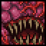
WALL OF FLESH
Arena: A long arena in the Underworld: 500 to 1500 blocks long depending on your difficulty, the arena can be made of either platforms or blocks. In Expert+ difficulty, if the arena is made of platforms, it shouldn't be made of Wood Platforms, If the arena is made of blocks, there should be gaps in the arena every 30 or so blocks to prevent Lava from Lava Slimes ruining the arena. The blocks themselves can be made of either Sand or Ice depending on if you have Dunerider or Frostspark Boots. You can also fight with no arena if you use Terraspark Boots or Water Walking Potions and just walk on the Lava, but either way you do it, it's recommended to use Dynamite or a Pickaxe to clear out the Towers in the Underworld, they will become a problem if you decide to fight the Wall of Flesh without clearing them out first, as they will prevent your movement.
For more specific positioning of your platform layout, see the specific strategies section below.
Tips: for the fight, horizontal mobility matters a lot, especially for Expert+ Difficulties, so methods to increase your speed anyway you can are recommended. Dunerider Boots on a Sand Block arena, Golf Cart, Magiluminescence or Panic Necklace for mobility, or Frostspark Boots if you use an Ice Block arena are all good ways of doing so. A block arena made of Sand, Ice or Stone have another perk of giving you a place to farm for Souls of Light and Night in Hardmode. As for his Lasers, it's mostly just about keeping your distance and jumping up and down to dodge them, timing is key

Note for Summoner and Melee users: as these classes require the player to stay relatively close to the Wall to get optimal damage, it is recommended that Shield of Cthulhu is not used, since it is very easy to accidentally dash into the Hungries or Leeches of the Wall, knocking the player into the Wall’s high contact damage. Instead, use another method to increase your acceleration, such as Magiluminescence or Sweetheart Necklace to replace that accessory slot.
Specific Strategies:
-Wall of Flesh’s lasers will tend to be the most annoying part of the fight, as they can reset your momentum while also dealing frequent damage if you don’t have a Cobalt/Obsidian Shield or high defense
There are two easy ways that you can negate the lasers.
The first way is by making your line of platforms center to the mouth of the Wall of Flesh, this way, the lasers will cross between themselves and miss you as long as you run fast enough, this strategy works well for Melee and Summoner users who have to stay closer to the Wall to deal high damage.
It is recommended to test summon the Wall first, to see where the mouth will stay during the fight and make your arena afterwards.
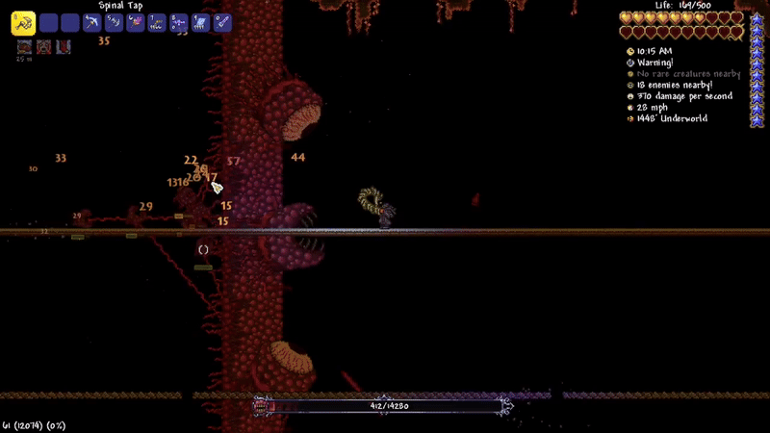
The second method works better for long ranged weapons, and involves using doors and hammered platforms to block the Wall’s line of sight to shoot lasers at you, just place any platform next to the door and hammer each of them once, this will make your projectiles able to pass through the door, more than 3 platforms can be added if you are using a weapon that shoots a large projectile so that it can fit. A ceiling can also be added if you want to be safer from the top eye.
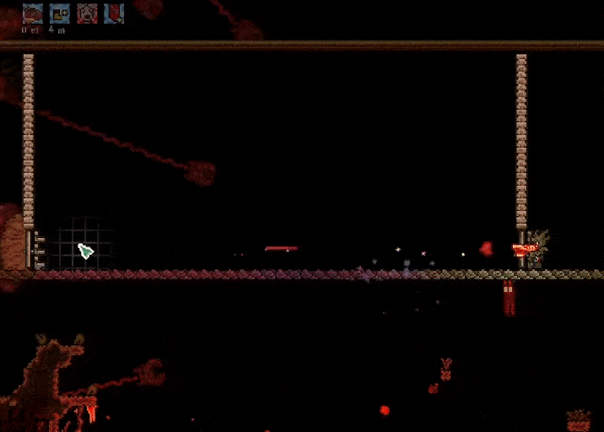
Mounts:
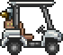 Golf Cart: grants excellent control over acceleration and speed. Making it one of the best mounts for Wall of Flesh
Dark Mage’s Tome (if Master Mode): can be used as a replacement for Golf Cart on Master Mode, as it takes less time to obtain, has the same horizontal speed, and synergizes with Extra Jump accessories. Just keep in mind that it can’t stand on platforms
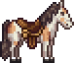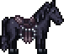
Any Horse Saddle from the Zoologist: higher max speed, allowing for outspeeding the Wall of Flesh on Expert+ but recommended to use some type of dash like the Shield of Cthulhu to get better acceleration before mounting
Lava Shark: the fastest mount available, but will require cleaning out the blocks of the underworld to make room to swim with it
(effective on Drunk world due to the big lava lake already being available)

DREADNAUTILUS
Arena: multiple platform layers or just 1 layer over the surface of the Ocean water. Make sure to have enough room to dodge its projectiles. A large box can be additionally be built around the Ocean to block off other blood moon enemies from interfering.
Tips: the most dangerous part about this fight will be the Blood Squids that Dread summons, they are accurate with their shots and deal big damage if they hit. So keeping an eye out for them and killing them as quickly as possible throughout the entire fight will be vital for your survival. The other 2 attacks of Dread are more predictable and manageable, the dash can be dodged by jumping or running away at the right moment to go into the center of its orbit. It is recommended that you keep your distance when it performs its red projectile spray attack and try to find openings to squeeze yourself through to not get hit.
Example Video: Youtube
Specific Strategies: Although not as effective as it was prior to 1.4.4, tanking Dread is still a viable strategy if prepared properly by boxing yourself in, it can make the battle somewhat more manageable, due to Dread not being able to summon the Blood Squids unless it has an unobstructed line of sight with the player, making the only things you have to tank being just the dash and the spray of red projectiles. the area around the box should be in the air so that other enemies won't interrupt, with a Campfire, a Heart Lantern, Honey inside the Box, a Bast Statue (Optional) and Heart Statues (Optional but helps immensely) near or inside the box. This can be expanded on by using a vertical tunnel as a way to dodge the dash as well, although you do have to manually time it, it drastically improves the strategy and can even work with Spiders Staff if Background Walls are added.
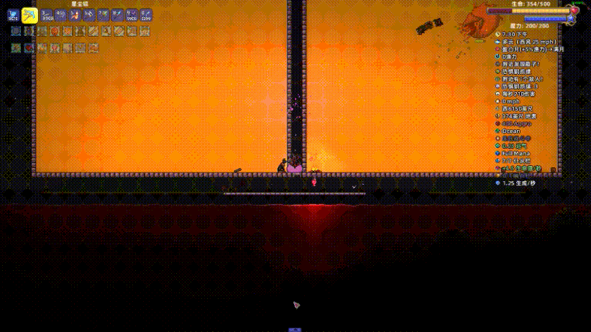
As for Gear for this strategy, it is recommended to use the sets provided in the Tank Builds folder
Weapons should be anything that can be used through blocks to hit Dreadnautilus reliably.
Examples are Daedalus Stormbow, Meteor Staff and Flying Knife or a Yoyo
Whips and Minions (if positioned outside) already go through blocks by default.
Sentries and Passive support Mage weapons also are very good for this strategy.
Mounts:
 Winged Slime (if Queen Slime defeated): balanced horizontal and vertical mobility, can also be used for faster downwards descent
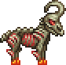
Unicorn & Goat: can be used to quickly gain distance
The following Mounts are best used with Bundle of Horseshoe Balloons:
Golf Cart: amazing mobility both acceleration and speed wise, has long invincibility frames after ramming
 Basilisk: amazing mobility both acceleration and speed wise, has an extra jump
Wolf: better acceleration and speed than both Golf Cart and Basilisk

QUEEN SLIME
Arena: a long arena about 500 to 1000 blocks long, preferably this arena should be made out of platforms and be high up, away from the blocks below, as her projectiles can bounce back up and hit you otherwise.
Alternatively, fight her above the Ocean’s surface using a Water Walking Potion or Terraspark Boots.
A 3rd option is to cover the floor with a thin layer of Lava, this will still cause the projectiles from Queen Slime herself to be an issue, but it will help to deal with her smaller slimes. An Obsidian Skin Potion, Water Walking Potion, or Terraspark Boots is going to be needed to use this strategy.
Tips: Queen Slime is a very projectile heavy boss, so you'll want to avoid getting too close to her for the fight, the long arena method mentioned above can be used alongside the Unicorn or Goat Mount (Horse Mounts from the Zoologist also work for this strategy as a budget option), keep running in 1 Direction and use a long range weapon to hit her, the arena being high in the sky is to prevent her projectiles from bouncing around, but instead just drop to the surface below where it can't reach you, this method may not work as well for Summoners who don't have Sanguine Staff as Abigail with a low minion slot count and Spider Staff can't hit her reliably in Phase 2.
Specific Strategies:
the fight can be nearly trivialized entirely by building a box with sloped blocks in the middle, the bottom 2 sloped blocks being spaced 4 blocks apart and hammered into any sloped variant. Staying under the bottom sloped block will make a majority of Queen Slime's attack never be able to hit you, occassional projectiles will slip through from her minions, but not enough to be fatal. While under there, weapons that can fit through a 1 block gap can be used to hit Queen Slime through the hole, but rain type weapons such as Daedalus Stormbow and Meteor Staff also work.
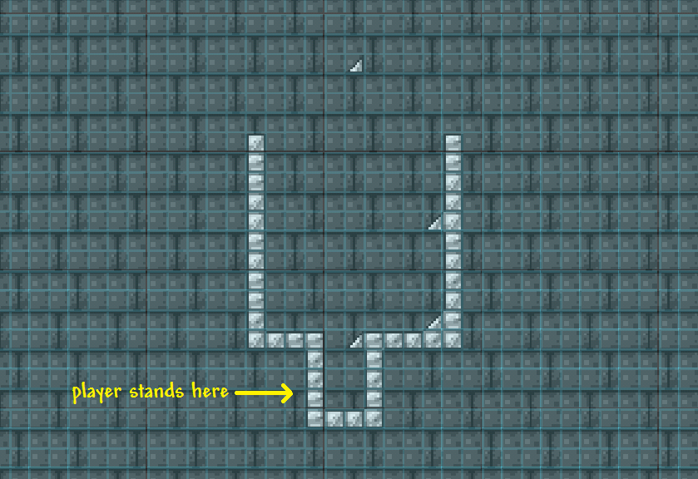
Example Video: Youtube (older design but the concept is the same)
An alternative design: Youtube 2
Mounts:
Unicorn & Goat: can be used to quickly gain distance, very effective for Queen Slime’s 2nd phase if used on a long bridge in the sky (Horse Mounts from the Zoologist also work for this strategy as a budget option)
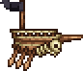Pirate Ship (if Master Mode): effective for 2nd phase, used to hover in the air to not have to worry about projectiles bouncing back up
The following Mounts are best used with Bundle of Horseshoe Balloons:
Golf Cart: amazing mobility both acceleration and speed wise, has long invincibility frames after ramming
Basilisk: amazing mobility both acceleration and speed wise, has an extra jump
Wolf: better acceleration and speed than both Golf Cart and Basilisk

MECHANICAL BOSSES (THE TWINS, THE DESTROYER, SKELETRON PRIME)
Arena: a long arena about 500 to 1000 blocks long, after 1 Mechanical Boss has been defeated, can be the arena can be turned into Asphalt Blocks for faster ground speed.
For Destroyer, an arena is optional but it is generally recommended to build a small platform around 150 blocks above the surface.
Tips:
For The Twins: move diagonally while constantly ascending or descending to dodge their projectiles. Make sharp turns and corners when they are dashing at you. Spazmatism should be targeted first.
For The Destroyer: using a piercing weapon is highly recommended for this boss, but a secondary weapon that is accurate or has a big hit box is also good to deal with the Probes. When it spawns in, a very high amount of damage can be dealt to the boss by hitting the coiled up section of where it spawns in with a infinite piercing weapon (Life Drain, Drippler Crippler, Star Cannon, etc), sometimes being able to kill the boss in seconds, this does require a bit of luck and precision to pull off unless you remove all other possible spawn locations of the Destroyer to just 1 block, an easy way to do this is to go up to space, avoiding any sky island, and placing a block just off of the screen, around 36 blocks downwards, this can be combined with the Dynamite strategy listed below.
Cross Necklace or Star Veil is a very helpful accessory for the fight because it can mitigate the amount of hits taken during the boss’s laser spam. good mobility is also good in general to dodge the laser spam.
For Skeletron Prime: dodging is very similar to regular Skeletron, avoiding getting stunlocked by his skull, and paying attention to where his hands will swing. However, there is one new thing to worry about. That being the Prime Laser, it can be quite annoying due the projectile’s fast velocity ruining your momentum (if you don’t have knockback resistance), so taking it out first is usually the best course of action.
*if you do get hit by the skull and get stunlocked, use one of the Slime Mounts (Slimy Saddle or Gelatinous Pillion) or use a hook to get out quickly.
Another thing to note about Prime is that his speed will rise exponentially to catch up to the player if they are too far away, due to this, it is advised to keep Skeletron Prime mostly on screen for the duration of the fight, else his contact attacks can become hard to react to.
Specific Strategies:
Destroyer can be somewhat trivialized by building a box a couple of blocks into the air (50 blocks is the recommended height, but higher doesn’t hurt), with some chests on some blocks at the bottom of the screen around 25 blocks below the box, throw dynamite onto those chests through a 1 block gap to hit the Destroyer, on higher difficulties, a weapon that can deal with the probes relibly is needed if not insta-killing
Example Video: Youtube (Short Guide) or Youtube (Longer Guide, much more detailed)
Gravitation Potions can make the process of dodging the projectiles of The Twins and The Destroyer easier due to allowing more range of movement.
Retinazer’s 2nd Phase can be made basically harmless by hiding inside of a box/blockswapping a platform that you’re hooked onto. This also applies to Destroyer’s lasers, though its contact damage and probes can still hit you directly.
Example Video: Youtube
Mounts:
Winged Slime: balanced horizontal and vertical mobility, can also be used for faster downwards descent
Unicorn & Goat: can be used to quickly gain distance
The following Mounts are best used with Bundle of Horseshoe Balloons:
Golf Cart: amazing mobility both acceleration and speed wise, has long invincibility frames after ramming
Basilisk: amazing mobility both acceleration and speed wise, has an extra jump
Wolf: better acceleration and speed than both Golf Cart and Basilisk

PLANTERA
Arena: a vertical rectangle arena with multiple layers of platforms, around 150 blocks high and 100 blocks wide. The platforms layers should not be spaced too close to each other, as that will make descending slower. There should also be a bit of room between the bottom platform layer and the block floor, as Plantera’s Thorn Balls can bounce back up and hit you otherwise.
An additional tunnel on any side of the arena can also be made to be entered when Plantera transitions to her 2nd phase. It can be used to avoid having to circle around her in this phase, at least not more than once.
If you accidentally make the arena too large to the point where it is not an Underground Jungle biome anymore, you can place 140 blocks of Jungle Grass Blocks or Hive Blocks which are actuated to fix the issue.
Note: if you try to build background walls for the arena to prevent mob spawns, it will allow Plantera more mobility in Phase 2, as she can use those as latching points for her hooks.
This isn’t as much of a factor if you use the Tunnel strategy
Note 2: If you fail the first time and your next bulb generated far away from your existing arena, you can break the bulb, then recall/magic mirror back to the arena using a set spawnpoint there with a bed. As long as Plantera does not enter your screen, she will have an increased timer which will not allow her to despawn for several minutes, allowing her to follow you back to your existing arena.
Tips: Phase 1 is rather simple as just circling will be enough to dodge all of her attacks in this phase, as mentioned above though, be careful of her Thorn Balls as they can bounce off the blocks at the bottom of the arena. Phase 2 is when the actual danger begins, it is possible to continue circling around her at this stage, but it might be a fair bit more difficult due to her tentacles.
Specific Strategies: The tunnel strategy as stated above can be used for Plantera’s 2nd phase, the direction of which you go to avoid Plantera can be any of the 4 sides of the arena, but if a downwards tunnel is made, it is recommended that a Featherfall Potion be used to have better control over your descent speed.
Note if using downwards tunnel: make sure to have a bit of a wall covering the sides of the entrance of the tunnel, as the Thorn Balls are able to fall into the tunnel, hitting you on the descent.
Example Video: Original or Youtube
For Melee users, it is possible to use Fetid Baghnakhs or Drippler Crippler (Drippler has to be spammed used upwards) to facetank Plantera provided the player has enough Damage Reduction and Regeneration.
Example Video:
Fetid: Original or Youtube
Drippler: Original
comparison between the two: Footage by Kepples
Mounts:
Winged Slime: balanced horizontal and vertical mobility, can also be used for faster downwards descent
Pirate Ship (if Master Mode): decently effective at circling Plantera
The following Mounts are best used with Bundle of Horseshoe Balloons:
Golf Cart: amazing mobility both acceleration and speed wise, has long invincibility frames after ramming
Basilisk: amazing mobility both acceleration and speed wise, has an extra jump
Wolf: better acceleration and speed than both Golf Cart and Basilisk

GOLEM
Arena: a platform layer can be placed near the ceiling of the Golem room to keep your distance from Golem when fighting. If the Golem room generates weirdly (too small to fight in), it is possible to build an external arena below or to the side of the Golem room. You can then summon Golem and teleport out using a Rod of Discord or Recall to a spawn point set outside in the arena. Hoiking out is also an option.
Example Video: Horizontal or Vertical
Similar to Plantera, if the external arena is too large, you can place 140 blocks of Jungle Grass Blocks or Hive Blocks which are actuated to not enrage Golem.
Tips: Golem is fairly simple to dodge, just move left and right to dodge his fireballs, fists and lasers. Using a platform layer above him to stand on to do this makes it easier, it is recommended to focus on his hands first, as they will get much more dangerous if not dealt with.
Sentry type weapons (Nimbus Rod, Clinger Staff, Rainbow Gun, Queen Spider Staff) are very effective against Golem due to his fight being usually restricted into a tight space.
Specific Strategies: For Melee users, setting up a 15x15 box above the altar, with the bottom of the box be made of platforms, and under there place a 3 tile long minecart track with the ends hammered 2 times each. After getting to top speed on the minecart track, spawn Golem and use a Shadow Jousting Lance to quickly deplete his health. This setup doesn’t require much besides a few survivability potions and enough defense.
An alternative way to box Golem in is to build this, the hoik will trap Golem’s horizontal position and additionally mostly prevents him from using his fists. This method also allows for hitting Golem with other weapons, other than just a lance.
(the platforms are invalid platforms, created by block swapping a sloped block in a certain orientation)
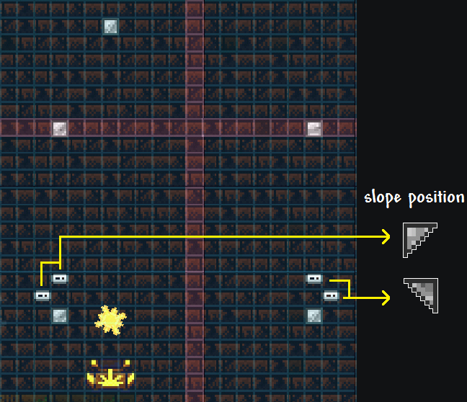
Example Video: Original
Mounts:
Winged Slime: balanced horizontal and vertical mobility, can also be used for faster downwards descent
The following Mounts are best used with Bundle of Horseshoe Balloons:
Golf Cart: amazing mobility both acceleration and speed wise, has long invincibility frames after ramming
Basilisk: amazing mobility both acceleration and speed wise, has an extra jump
Wolf: better acceleration and speed than both Golf Cart and Basilisk
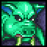
DUKE FISHRON & EMPRESS OF LIGHT
Arena: For Duke Fishron, multiple platform layers or just 1 layer over the surface of the Ocean water. The bottom layer can be made out of Asphalt. Arena is optional if using Water Walking Potion or Terraspark Boots.
For Empress of Light, the same arena used for the Mechanical bosses can be used for her. The floor for the arena can be made of Asphalt.
Tips: Duke and Empress are both skill based bosses, easy to no hit if you understand their patterns, but very difficult if you don’t. Due to the high damage for each of their attacks, even tanking them is difficult to do. Since there are many intricacies to their attack patterns, it is recommended that you check out these videos for details on dodging them.
Dodging styles that don’t require as much practice:
DUKE FISHRON (GUIDE - TRICK) in Master Mode with Pre-Plantera Build - Terraria 1.4
EMPRESS OF LIGHT (Day Form GUIDE) in Master Mode with Pre-Golem Build - Terraria 1.4
(for the Empress of Light video, the Rod of Discord can just be substituted for any method of fast horizontal movement (Asphalt with Movement Speed Buffs, Hexxed Branch))
Dodging styles that are much more strict but don’t require as much setup/gear:
Duke: Terraria - 1HP Master Hardcore in 2:06:39 (Seeded, NMA)
Empress: Terraria - 1HP Master Hardcore in 2:06:39 (Seeded, NMA)
Good mobility is highly recommended to dodge their attacks if you get caught off guard. Infinite flying mounts such as the Witch’s Broom are quite effective for Empress of Light, though not as much for Duke, as he is easier to dodge using sharp turns and corners, something easier to do using Wings.
Specific Strategies:
However, not all mounts are useless for Duke. On Expert+ difficulties, his 3rd phase can prove quite panicking for players not familiar with it. To help deal with it, using the Gelatinous Pillion or Golf Cart mount can help. Shield of Cthulhu is also an option though somewhat harder to pull off.
Example Video: How to [neutralize] Terraria's Duke Fishron Phase 3, in brief or Original 1 and Original 2
*note for Golf Cart: when ramming into Duke in his 3rd phase, the granted invincibility frames can be interfered if you are using a piercing weapon yourself. As a result, weapons that don’t pierce are recommended when using this strategy. (Minions and Melee weapons also count as piercing projectiles)
Mounts:
Witch’s Broom (if Expert+ Mode): better for Empress than it is for Duke, grants great control over aerial movement
Or 
Unicorn or Tree (if Master Mode): can be used to quickly gain distance
Winged Slime: good for Duke’s 3rd phase, also good for downwards descent on Empress
Golf Cart: good for Duke 3rd phase
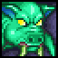
DUKE FISHRON (PRE-MECH) & EMPRESS OF LIGHT (DAYTIME)
Arena: For Duke Fishron, multiple platform layers or just 1 layer over the surface of the Ocean water. The bottom layer can be made out of Asphalt. Arena is optional if using Water Walking Potion or Terraspark Boots.
For Empress of Light, the same arena used for the Mechanical bosses can be used for her. The floor for the arena can be made of Asphalt.
Tips: note that these fights should only be attempted after having familiarized with to the normal versions. And most of the strategies from the regular fight still applies to these version of the fight.
For Duke Fishron, high mobility is one of the important factors to increase your chances of survival, so Crystal Assassin armor is a solid consideration, especially for non-summoner classes.
For gear, the recommendations don’t change much from what you’d use for the Mechanical bosses. Weapon wise, weapons that are effective for The Twins and Skeletron Prime will also be effective for Duke Fishron.
*note for Rangers: Ichor Bullets will be better than Crystal Bullets in this fight if your damage bonus isn’t that high, due to Duke’s high defense making the shards do minimal damage for weapons of this stage.
Note that Tank Builds will likely be ineffective due to Tanking gear at this stage being not sufficient enough to protect you from that many hits from Duke, so specializing into mobility and damage is more recommended.

For Empress of Light, try to specialize only into mobility and damage, as no gear or strategy will allow you to survive a hit from Empress as of the latest update.
Like regular Empress of Light, mobility will be greatly appreciated for the fight, if on Expert or above, using the Witch’s Broom or Wings with the Soaring Insignia is a solid strategy due to the excellent control in movement that gets granted
Here’s a video that simplifies dodging Empress of Light in the day using Witch’s Broom:
How to (somewhat easily) demolish Daytime Empress of Light in Terraria
*note for accessory loadout mentioned in video: replace Berserker’s Glove with Hercules Beetle
Mounts:
Witch’s Broom (if Expert+ Mode): grants great control over aerial movement for Empress
Or
Unicorn/Goat or Tree (if Master Mode): can be used to quickly gain distance
Winged Slime: good for Duke’s 3rd phase, also good for downwards descent on Empress
Golf Cart: good for Duke 3rd phase

LUNATIC CULTIST
Arena: you can use your Skeletron arena, expand it a bit if needed.
Tips: most of his attacks can be dodged by circling, though for the summoning rituals where he summons his decoys, there are some tips you can remember to help with identifying the real Cultist:
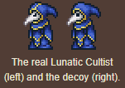
-the real one has angry/sharp looking eyes while the decoys have square ones
-the decoys emit light, the real one does not. So keep that in mind if fighting at night time
-the real one has an extra yellow stripe on the top of his hood, the decoys do not
Also note:
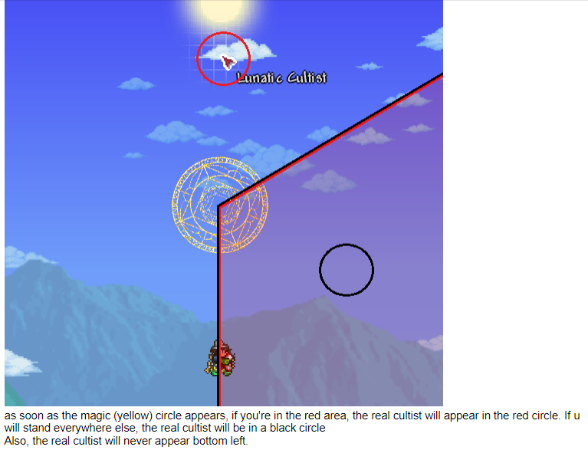
Example Video: Youtube
Mounts:
Witch’s Broom (if Expert+ Mode): grants great control over aerial movement
Cute Fishron (if Expert+ Mode): grants great aerial mobility + a damage boost, but only if water pockets are set up or it is raining during the fight
A riskier strategy is to keep your health below 50% to get the boost, accessories like the Frozen Shield synergizes well with this method
Winged Slime: good for downwards descent

MOON LORD
Arena: same arena for the Mechanical bosses and Empress of Light can be used. It can be made out of Asphalt
Tips: begin the fight by running either left or right while lowering the health of the eye on that
side, try to keep Moon Lord’s top eye near the edge of your screen at max zoom out, and focus on the top eye when it opens up, pay attention to when the top eye gets ready to fire its Phantasmal Deathray (it will look straight at the camera before firing) if you get hit by this, your chances of dying are very high, you can either fly over it to dodge or use a Rod of Discord. teleporting to the spawnpoint is also an option, but it is risky (although can be made safer if the Nurse NPC is placed at your spawnpoint), repeat this until all 3 Eyes are at low health, balance them and try to pop them out all at around the same time (note that the top eye has more health than the other two), for Phase 2, just run in 1 direction and do not turn around unless you absolutely have to (hitting the world border), ditch the arena, and run for your life while hitting his Core from afar, your main objective is to survive the mini deathrays that the True Eyes of Cthulhu shoot out, they are near impossible to fly over, cover a massive radius and deal massive damage,so just running in 1 direction to get out of the deathray's range is the best option. For their other attacks, just moving up and down repeatedly will suffice, additionally, moving up and down in a zig zag pattern does help to get away from the True Eyes faster, due to them not having good vertical mobility.
For Melee users using Flying Dragon, it is recommended to try to hit 2 eyes of the Moon Lord with 1 projectile as much as you can when using the weapon, as that is how you are going to out damage the other options available, if this is makes the fight’s movements too restrictive for you, it is advised to use a different weapon.
Specific Strategies: In Expert Mode and Master Mode, all attacks of the Moon Lord have their damage doubled and tripled respectively, except for the contact damage of the eye socket, which deals 80 as in Normal Mode. It means that if your defense is higher or equal to 106 (in Expert) or 79 (in Master), you will only take 1 damage from it while triggering invincibility frames. To utilize this, you need: armor and accessories setup with at least 106 (in Expert) or 79 (in Master) defense, A Cross Necklace (or Star Veil) which elongates invincibility frames, a shield that prevents knockback (such as Cobalt Shield or Paladin’s Shield), and enough mobility (infinite flight: Witch’s Broom recommended) to keep up with the movement of the eye socket. You will have to somehow take out one eye to use this strategy, though. After that, you can just follow and touch the empty eye socket while shooting at other parts of the boss.
Example Video:
Moon Lord Made Easy - Terraria Master Mode + For The Worthy
Due to Moon Lord’s spawn timer, stacking lingering projectiles before he spawns in to get in extra damage is quite effective, one of the easiest ways to do so is with Nebula Arcanum, as you can store the projectiles in a box before the Moon Lord spawns in. Resulting in massive chunk damage at the beginning of the fight, potentially even killing his top eye immediately if you have enough damage bonuses.
It is possible to stay close to the Moon Lord and predict and dodge every attack he performs, alongside popping the True Eyes of Cthulhu out at the perfect time to sync their attacks making them much easier to dodge, this requires a lot of practice and memorization of Moon Lord’s attack patterns but can be useful for more experienced players
Example Video:
문로드 패턴회피 연습 종료
Mounts:
Witch’s Broom (if Expert+ Mode): grants great control over aerial movement
Cute Fishron (if Expert+ Mode): grants great aerial mobility + a damage boost, but only if water pockets are set up or it is raining during the fight
A riskier strategy is to keep your health below 50% to get the boost, accessories like the Frozen Shield synergizes well with this method
Winged Slime: good for downwards descent

EVENT STRATEGIES
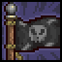
EARLY EVENTS (GOBLIN ARMY & PIRATE INVASION)
Arena: a flat area around 100 to 200 blocks long with a platform layer above, similar to Eye of Cthulhu/King Slime’s arena or a Volcano Trap:
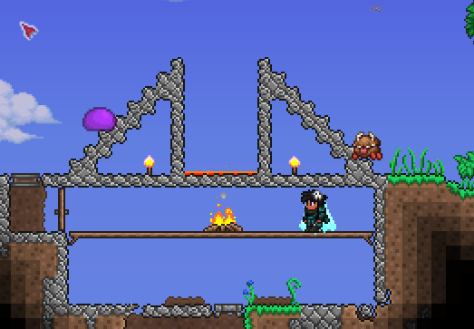
Tips: the events should be fairly simple as long as you have a good crowd control weapon, having the high ground is recommended as to not get surrounded by the contact damage enemies, as well as have more room to dodge the projectiles.
For the Goblin Army, the Spiky Balls that the Goblins drop can be used on the Goblins themselves, as they linger for a long time and have high pierce.
With the Volcano Trap strategy, the only thing you have to worry about are Goblin Sorcerers and the Pirate’s Curse which aren’t too threatening on their own.
A rain type weapon such as Daedalus Stormbow or Meteor Staff can be used if hitting the Flying Dutchman while under the Volcano is too difficult

HOLIDAY MOONS (PUMPKIN MOON & FROST MOON)
Arena: a flat area around 300 to 500 blocks long with a platform layer above.
Tips: try to stay constantly airborne and don’t stop moving, as the enemies can unpredictably fire fast projectiles from off-screen that are difficult to be able to react to. So having good mobility is an important criteria before doing these events.
It is recommended to use good crowd control weapons for the enemies while good single target weapons for the bosses, though some weapons fufill both roles (Terra Blade, Stynger, Staff of Earth, Deadly Sphere Staff)
for the Morning Woods, Everscreams and Santa-NK1, you want to move in a sort of swinging seesaw pattern, dodging their projectiles as a main priority, since they're mostly stationary targets, getting as much damage on them as you can should be not too difficult and should be focused on before the flying bosses spawn.
for the Pumpking and Ice Queen. Pumpking can be treated similar to Skeletron or Skeletron Prime, circling should be your main strategy, though his hands should be watched carefully, due to them being much more of a threat compared to Skeletron's.
Ice Queen will try to stay above you when fighting, running in 1 direction can help for attacks where she tries to drop projectiles from above, though for her attack where she spins and sprays icicles, you can try to stay and pray that you don't get hit, while getting good damage on her, or hide behind some blocks or away from her to recover some health

MARTIAN MADNESS
Arena: either the arena you used for the Holiday Moons (it is recommended you do those Events first) or set up a box made of blocks, then place a line of platform next to the inside part of the wall of the box, and hammer each of those platform once, this will allow projectiles to be shot through to the outside, but projectiles from the enemies will not be able to reach inside, if using a Melee Weapon or Whip, hammering the blocks will give the same effect (although this only works on Mobile and Console), Teleporters can also additionally be hooked up inside the box to help with dodging the laser of the Martian Saucer, and one for exiting the box when needed
Example Video: Original (Projectile works for all platforms, Whips and Melee only works for Mobile and Console)
Tips: this is a rather difficult Event, so it is recommended to do it after the Holiday Moons, but before Duke Fishron and Empress of Light to make the most use of the drops. A large amount of enemies in this event have the ability to shoot projectiles, so non-stop movement is required if you are not using the box strategy, but the main threat and reward will be the Martian Saucer, a majority of its attacks can be dodged somewhat easily by circling (minus the Laser), the Boss might take a bit to get used to if not using the box strategy mentioned above, but a big part of learning how to dodge its attacks will come once you get the timing down, if using the box strategy, use the Teleporters to your advantage to dodge between the laser when it comes in your direction.
if on Expert+, it will have a Phase 2, which will be much harder if you are not prepared, once it begins transitioning, try to fly away from it to give yourself some time to react when it begins to spam its laser, this attack is comparable to Moon Lord's Phantasmal Deathray, usually killing the player in one hit on high difficulties, when done transitioning, it will fire its laser rapidly, the way to dodge this is by going back and forth between the Laser everytime it deactivates, an Infinite Flying Mount is highly recommended due to being able to stay in the air, away from the normal enemies, not giving space for them to interrupt you when dodging the Saucer. A platform in the sky can also be used if you do not have a flying mount, but this will limit your movement somewhat as you’ll also have to deal with the sparks from the Saucer, though once you get into a rhythm, it should not be too bad.
knockback resistance is also important not to lose your momentum if you get unlucky with the falling Sparks that it sprays out
A video example of phase 2 using a flying mount can be seen here
Mounts:
Witch’s Broom (if Expert+ Mode): grants great control over aerial movement
Cute Fishron (if Expert+ Mode and Duke Fishron defeated): grants great aerial mobility + a damage boost, but only if water pockets are set up or it is raining during the fight
A riskier strategy is to keep your health below 50% to get the boost, accessories like the Frozen Shield synergizes well with this method

OLD ONE’S ARMY
Arena: must be a flat surface made of blocks, preferably 60 to 80 blocks on each side, you can place platforms on the top of the Ethernia Crystal so you can place Explosive Trap Staffs on there for flying enemies if you wish. Hoiks can be used to stop most grounded enemies, by placing a block on the ground, then hammering it 4 times on the right side portal, and 5 times on the Left side Portal, then using block swap to replace the block with a platform, the hoik should be around 10 blocks away from their respective portals
Example Video: Original or Youtube
Tips: a weapon that can pierce alot of enemies in a straight line is useful for the grounded enemies, a powerful or accurate weapon can be used for flying ones, and high single target damage weapons should be used for the bosses (Dark Mage, Orge, Betsy).
on the 3rd tier of the Old One's Army, the final boss Betsy, is recommended to be fought on a separate arena above the Crystal, she will either target the Player or the Crystal depending on which is closer to her during her attack, Betsy's Movements can feel sporadic and unpredictable due to this. So high mobility is recommended to be able to dodge her well, something with good homing capability or a big hit box might be helpful in hitting her, use everything to your advantage to take her out before the Crystal is destroyed, defeating Betsy is top priority as the event will end immediately once she perishes
Sentries to use in the event: the rankings of the Sentries goes as follows:
Best: Explosive Trap
Great: Ballista
Good: Flameburst, Lighting Aura
More info about each individual sentry is given below:
Ballista: Good Damage, Good Reliability. Has sufficient piercing to deal with a good amount of enemies, while also providing solid damage, although it is only decently effective for flying enemies if they come at it at the right angle, so placing a few Ballistas in the air to remedy this is recommended. If using Squire or Valhalla Knight armor, Damage is boosted up to Great tier.
Explosive Trap: Great Damage, Decent Reliability. Highest Damage potential of any sentry but also the lowest range, very effective for ground enemies, though needs good placement (either near the portal or near the crystal) to hit flying enemies. Sloped platforms can be used to place multiple Explosive Traps on the same tile.
Flameburst: Decent Damage, Great Reliability. Most reliable sentry for the flying type enemies, though doesn’t have as much crowd control potential as other sentries. Due to their long field of view, allowing them to hit enemies from far away, it is recommended to place them on a platform 12-15 tiles in the air, and far enough away that they can see the portal.
Lighting Aura: Good Damage, Good Reliability. Although it ignores all enemy defense. it is recommended to pair it with other sentries, utilizing more knockback to keep them in the Aura for longer. For Ballista and Flameburst Staff, they can be used like regular, but for Explosive Trap, it is advised to position them like this:
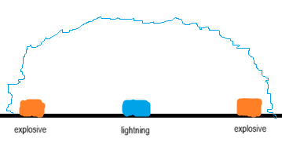
Do keep in mind: While Lightning Auras can be placed next to other Tavernkeep's sentries, it is not possible to place another Tavernkeep's sentry inside the radius of an existing Lightning Aura. Therefore, Lightning Auras should be placed last when clustering various sentries together.
Other than sentries from the Tavernkeep, using support magic weapons like the Clinger Staff, Nimbus Rod or the Rainbow Gun, alonside non-OOA sentries like the Queen Spider Staff and the Staff of the Frost Hydra is also recommended.
Mounts:
Tier 1:
Golf Cart: great acceleration and movement
Any Horse Saddle from the Zoologist: can be used to quickly go between the right and left portal
Tier 2 & 3:
Witch’s Broom (if Expert+ Mode): grants great control over aerial movement
Cute Fishron (if Expert+ Mode): grants great aerial mobility + a damage boost, but only if water pockets are set up or it is raining during the fight
A riskier strategy is to keep your health below 50% to get the boost, accessories like the Frozen Shield synergizes well with this method
Or
Unicorn/Goat or Tree (if Master Mode): can be used to quickly go between the right and left portal

CELESTIAL PILLARS
Tips: highly recommended that you have good crowd control, supporting Magic weapons and Sentries can work well to add every coverage.
High mobility is recommended and constant movement should be preformed if not using the specific strategies listed below.
For the Solar Pillar, always stay on the ground to avoid Crawltipedes from targeting you.
Specific Strategies:
Stardust: Lead a Star Cell away from the pillar and kill the adult cell, let the babies grow back to adults then kill the adults again. Repeat this process until the barrier is destroyed
Vortex: None of the vortex enemies can go through blocks so you can barricade yourself behind some blocks and use weapons that go through walls to kill all of the enemies. Do this until the barrier is destroyed.
Nebula: Start by approaching the pillar from the sky to avoid enemy's spawns, use an ice rod to place a block midair then build a 5x5 square with platforms, replace the middle platform on the left, right, and top with a solid block, then build down about 36 tiles and making a spawning platform. Swiftly move up and block swap the left and right platforms on the bottom so you are making a star pattern.
Example Video: Youtube
Solar: Start by approaching the pillar from the sky to avoid Crawltipedes, once inside place a block midair with the ice rod then build an L shape build that’s at least 20 blocks tall, layer the wall side of the L with platforms and hammer each of those platforms once.
After which, you can just sit back to attack the enemies from behind the wall using projectiles and only have to worry about the occasional Corites.
Example Video: Youtube
Mounts:
Witch’s Broom (if Expert+ Mode): grants great control over aerial movement
Cute Fishron (if Expert+ Mode): grants great aerial mobility + a damage boost, but only if water pockets are set up or it is raining during the fight
A riskier strategy is to keep your health below 50% to get the boost, accessories like the Frozen Shield synergizes well with this method

