The History of Jason’s Terraria Guide
1.Introduction
- Jason’s Terraria Guide is a Class Setups Guide created by Jasonthe4th, with the support of many members of the #Terraria-Help channel on the Official Terraria Discord.
- it is meant to be a Guide that covers nearly everything that a typical player will need to know when it comes to gear, mainly focused towards Boss Fights with minor coverage on Events as well, with the intent to be as accurate and detailed as possible while still not being too wordy.
- production of the project started on October 31st 2022 and has been getting frequent updates ever since, this document’s purpose is to archive the major events and milestones that the Guide has achieved over its 1+ year run.
2.History
+First Day
- on the night of October 31st 2022, Jason got the idea to make a Terraria Class Setups Guide, he has been on the Terraria Discord for a few months, ever since the 1.4.4 version release, just casually chatting on the Help channel to aid new players.
- at the time, he was only trying to make it for fun, having nothing else to do with his free time, and it might help a couple of people in the end, so there shouldn’t be any harm.
- he decided to start with Summoner, since that was the class that he was most familiar with at the time, having watched a lot of Shyguymask videos and having a good amount of personal experience with the Class himself
- he didn’t have much of a plan going into it, so he just threw together a format, something that seemed like it would give a good amount of space to put both Images and Text, usually Class Setups that are not on the Wiki tend to focus on either Text or Images, not both, making them either too much of a hassle to read, or hard for new players to decipher what items were what.
- first he made a template that could cover most of the details he wanted to include: armor, weapons, accessories and following a color scheme that resembles the Official Wiki.
- after adding the necessary items and text, he had something that looked decent.
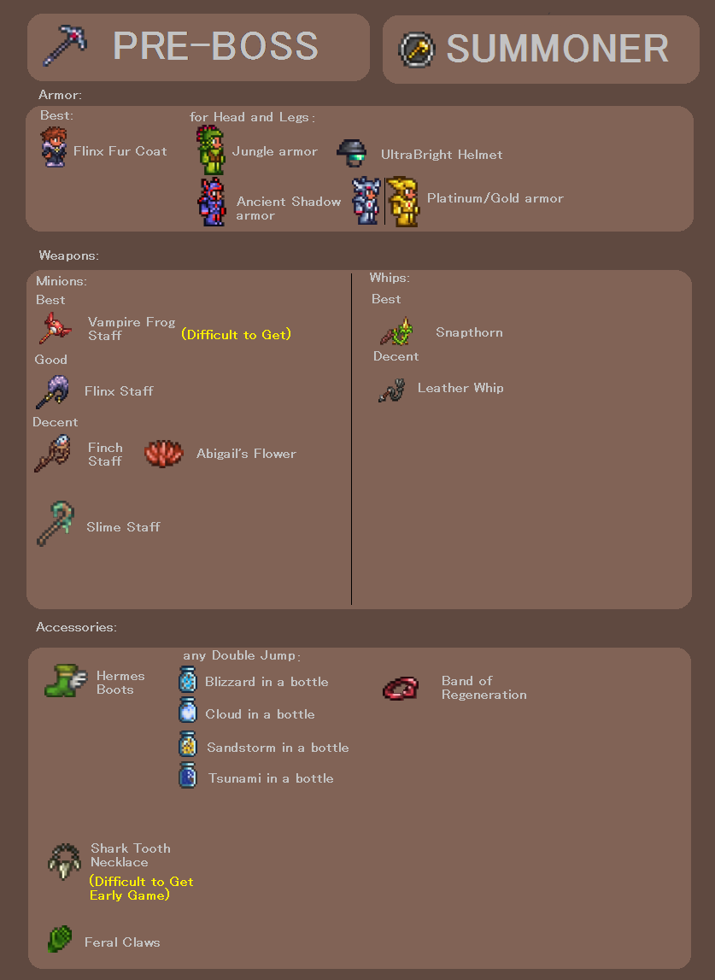
- at the same time when he was making this though, he was also chatting on the Discord, something that would become quite common with future updates, chatting and working on the Guide at the same time is quite a relaxing experience for him.
- he saw that somebody was asking for gear suggestions. on Summoner. Pre-Boss (or at least, close enough).
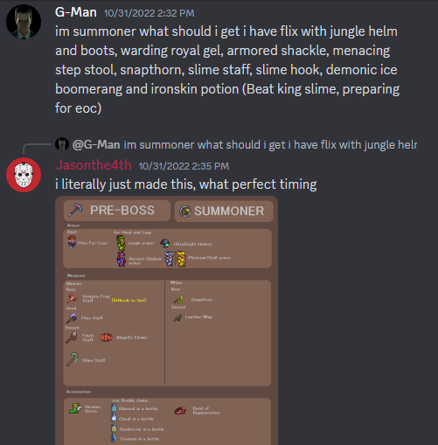
- it was like fate that there was the perfect opportunity to use it as soon as it was being made, but with that, the first day came to a close, with the first ever image of the Guide being created and put into use.

+Getting Pre-Boss, Pre-Wall of Flesh, Pre-Mech, Pre-Plantera, Pre-Golem and Pre-Moon Lord done (Version 1.0)
- over the next couple of days, Jason would continue working on the Guide, making the rest of the classes and their different stages.
- going in order of Summoner, Melee, Ranger and lastly Mage.
- but during all that, the Guide had already gained a lot of traction, people were asking for it more than Jason could have ever imagined when he started making it.
- though since it was still in very early development, Jason hasn’t gotten to compiling them anywhere yet, and was resorting to just sending all the images to people’s DMs.
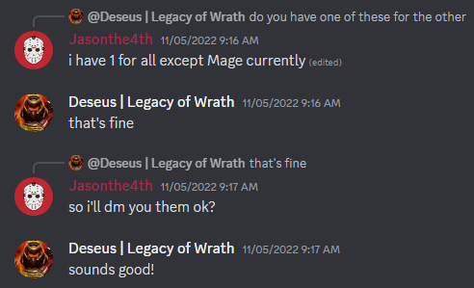
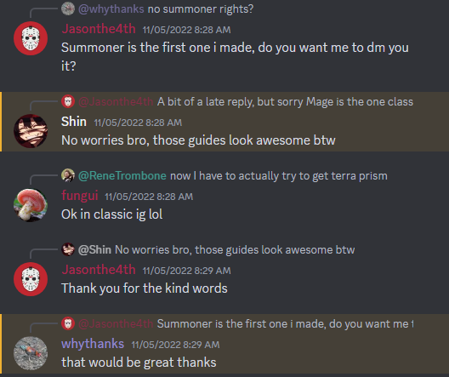
- eventually though, all the main stages and classes were finished, and while the Guide served its purpose, Jason still had more that he wanted to do with it, and so, he continued working.
- as a side note, the first person to ever get sent the 1.0 file was:
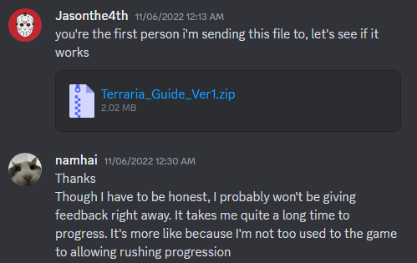
+Pre-Evil, Pre-Bee, Pre-Deerclops, Pre-Skeletron, Pre-Queen Slime, Pre-Dukempress and Pre-Cultist (Version 2.0)
- other Class Setup Guides tend to skip these stages, due to them not being too noteworthy enough to make a significant difference, however, since Jason’s Guide was a bit more detailed, it could cover these stages without them being complete copies of other stages around the same time.
- later on though (Version 4.0+) Pre-Queen Slime was removed, and Pre-Bee and Pre-Deerclops were combined into Pre-Beerclops, since those stages weren’t different enough for them to warrant their own pages.
- alongside these, an End-Game stage was also added, due to popular demand in Version 3.0.
And speaking of Version 3.0
+The thisisabadname Update (Version 3.0)
- around this time, Jason has finally gotten to compiling all the images into an easier to access way, a Google Drive Folder
- he was asking around the Discord for opinions on what should be changed/added, the first person to give suggestions was somebody who goes by “thisisabadname”, not only did he give a lot of ideas, enough for an entire major update, but continued to help with the development of the Guide in the future, with Jason and him still being in connections with each other to this day.
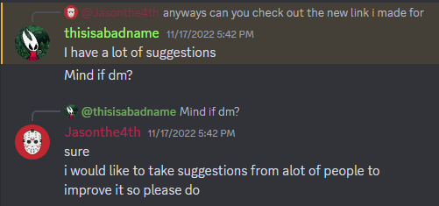
+The Golden Age (Version 4.0 to Version 7.0)
- the Guide was increasingly getting more and more attention, both within the Discord and outside of it.
- and as such, the thought of the Guide getting pinned on the #Terraria-Help Channel was thrown around quite a lot.
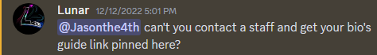
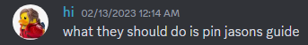
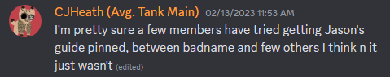
- around February 18th 2023, many supporters of the Guide started a group effort of sending messages to Mod Mail to suggest getting it pinned, with badname being the first person to do so.
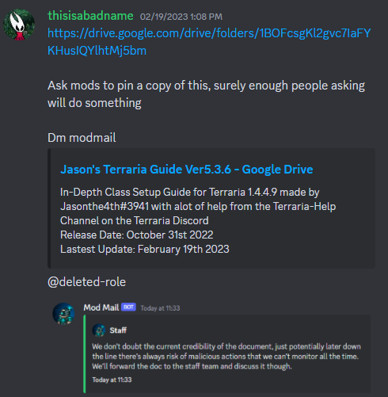
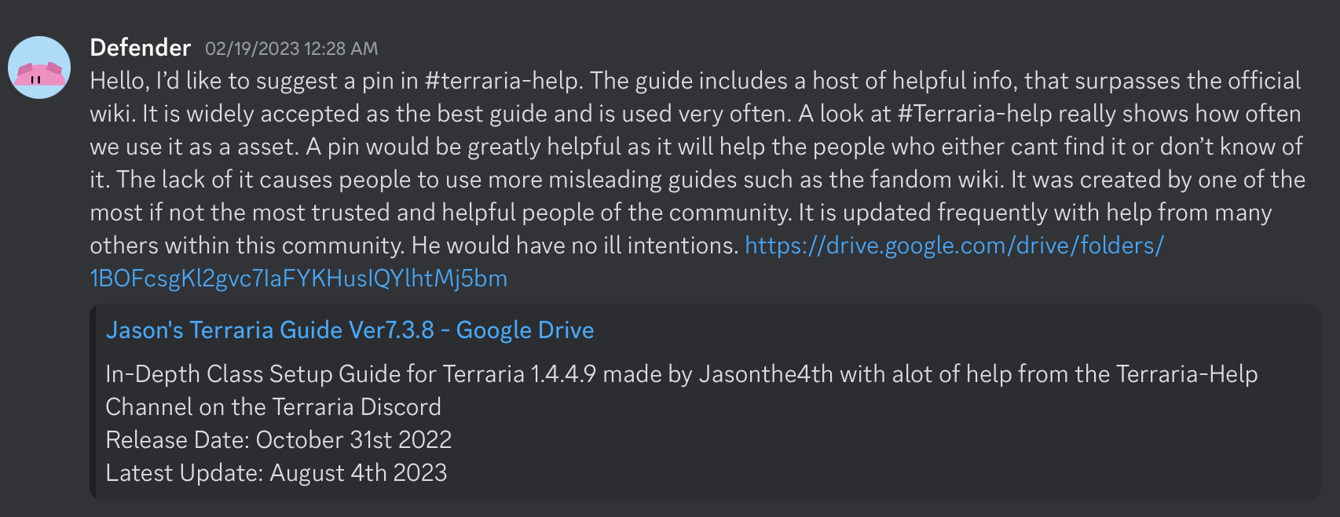
- eventually, the push to get it pinned actually got through, and the mods agreed to make a change, but, since User-Made content couldn’t be pinned on the Server, a compromise was made where a copy of the Guide would be made to be pinned instead, but even then, it’s close enough and still works functionally the same, so the compromise was accepted.
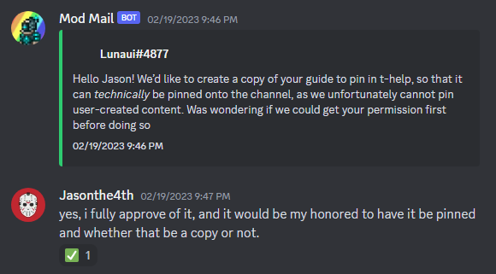

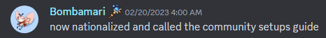
- around the same time, badname also got it to be mentioned on the Class Setups Page on the Official Terraria Wiki
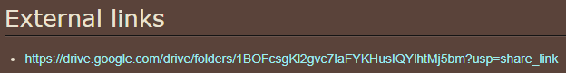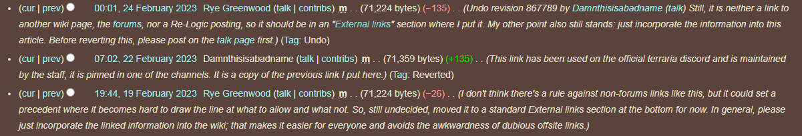

- as for the content of the Guide itself, many players who were more experienced than Jason were helping to improve the accuracy of the Guide, along with introducing new sub-classes such as Tank and Hybrid
- one of the people who helped the most during those times was CJHeath, contributing to many aspects of the guide, such as gear, strategies and many more
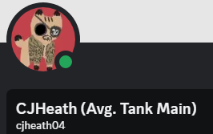
(massive contributions from 4.0 to 6.0)
- even though CJ has less involvement with the Guide now, another person has taken up the mantle.

(contributed from 6.0 to 7.0)
- TeWu helps mainly with armor suggestions and grammar/typo checking and has been a big help as a quality checker for the Guide in its modern day.

- another person to have contributed a lot to the Guide, even though somewhat indirectly, is Kep, his Guide documents all his tests on Bosses using a wide variety of weapons, these tests help to validate certain placements within Jason’s Guide and to bring more attention to other weapons that would’ve otherwise been ignored.
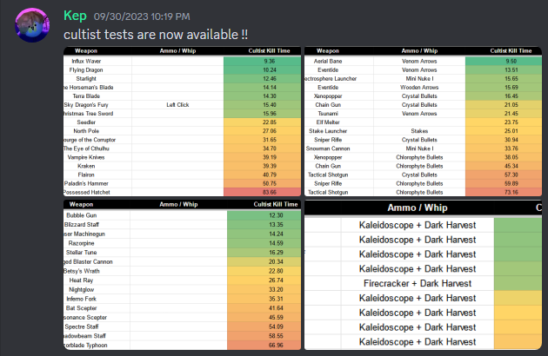
+The Terrasteel Incident
- a few months after the Guide was pinned, Terrasteel became a rapidly growing Terraria Youtuber, who is very respected for his knowledge about the game.
- one of his videos about Crystal Assassin armor, has a segment about comparing its stats to other sets and it had some mixed armor set sprites, Jason noticed something peculiar about them upon watching the video.
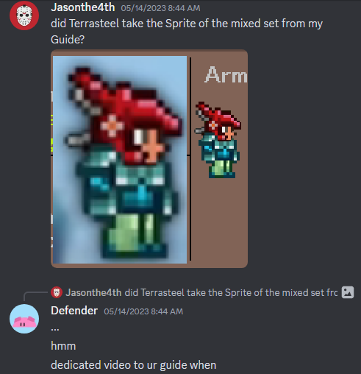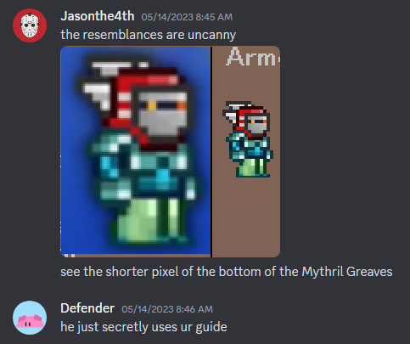

- in the end, this suspicion would turn out to be true in his video about Whip Stacking, released just a few days later
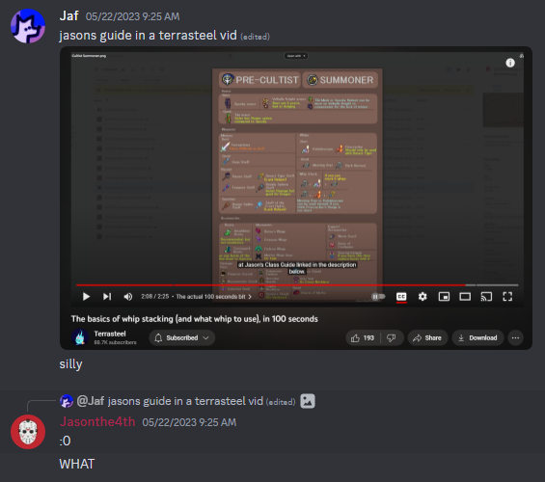
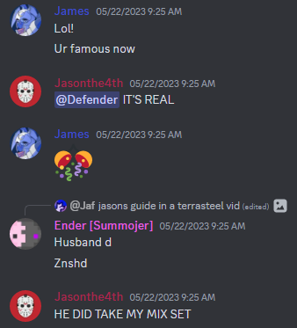
- around this time, other influential figures have also taken notice to Jason’s Guide
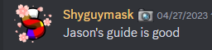
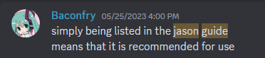

+The Blank Month (2 Months before 1 Year Anniversary)
- obviously, after working on the Guide for 9 months at this point without so much as a long break, burn out was going to get to Jason sooner or later.
- and so fate would have it that around this time, his main phone he uses to play Terraria broke, making his motivation to continue working on the Guide and chatting on the Discord to stagger.
- but at the same time, he felt that it was okay, since the Guide was in a state now where a majority of its information has been vouched for and changes for it were hard to find justification for.
- so, he decided to take a 1 month break, vanishing from both the Discord and the overall community, indulging into other forms of entertainment in the meantime.
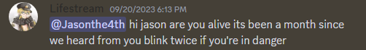

+1 Month before 1 Year Anniversary
- on 27th of September, Jason came back, now with new found determination to make the best update he could for the upcoming 1 year anniversary.
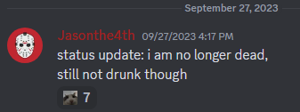
- alongside Kep releasing his Lunatic Cultist test results, other members were also enthusiastic to help out with suggestions, making the progress of the 8.0 update go rather smoothly
+A Word of Thanks (Update 8.0 release, 1 Year Anniversary)
Hi!
I’m the creator of Jason’s Terraria Guide, Jasonthe4th, I just want to really share some words of gratitude towards everyone who has supported, followed the development of, and used the Guide throughout all this time.
Ever since starting this project I never really expected it to be anything big, but that’s a bit late to be saying that now, huh?
It has been a rather busy year since joining the Official Terraria Discord and working on this, but I truly don’t regret all the time that I spent with this community and nurturing my work.
I’d gladly do it again if I could, but well, that’s what the future is for isn’t it?
Cheers to the Guide’s 2nd Year! 🍻
And now, a word from my proof reader:
Hi!
I’m TeWu, (tewu_ on discord), I just want to say that Jason is terrible at grammar and proof reading this document (and all the guide pages) has made me question Vietnamese education, that’s all.
+The Wait for Terraria 1.4.5 (Update 9.0+)
- Jason’s journey on updating the guide didn’t stop, despite no notable updates releasing for Terraria for quite some time. A place where he was getting much of the advice and suggestions from, was on the dedicated server for #Terraria-Help regulars, most notably, the members that contributed the most during this time were Yousef, Xyloph and Amaboye.
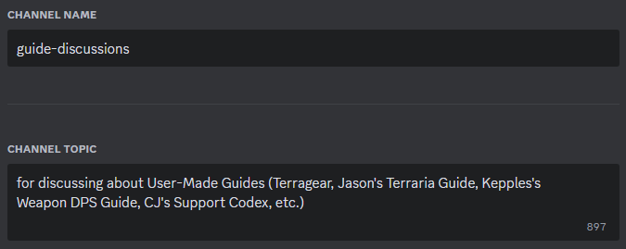
During this time, Jason’s reputation has also been getting more recognized, due in part of just the legacy that he had created, but also Sorbet Cafe making a mention to it in one of his videos
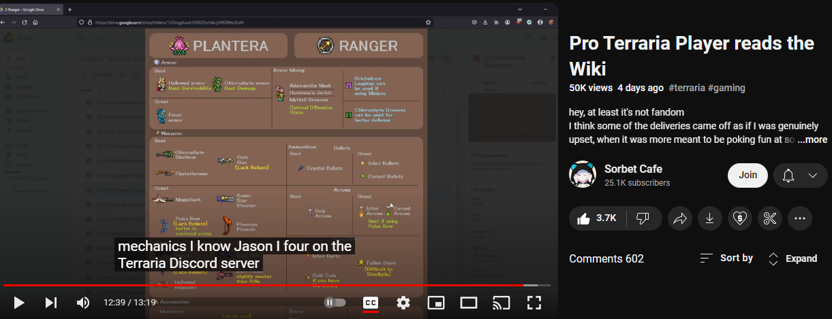
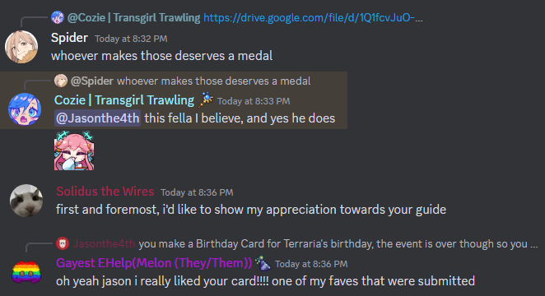
As of 12th of May 2025, Jason’s Terraria Guide is now officially pinned on the #Terraira-Help channel, no more copy version, huge appreciation goes to Salamatic for making that possible!
